8
The Calvary Chronicle
Share the Gospel – Prepare Disciples –
Serve All in Christ’s Love!
December 2022
Volume 86 - Number 12
La Crónica del Calvario
¡Compartir la palabra – Preparar discípulos – Servir a todos en el amor de Cristo!
Diciembre 2022
Volumen 86 – Número 12

One Church - One Congregation – One Chronicle
Una iglesia - Una Congregación – Una Crónica 5,12.19,26
12/04/2022- Second Sunday of Advent
Isaiah 11:1-10 Ps. 72:1-7, 18-19 Romans 15:4-13 Matthew 3:1-12
12/11/2022- Third Sunday of Advent
Isaiah 35:1-10 Ps. 146:5-10 James 5:7-10 Matthew 11:2-11
12/18/2022- Fourth Sunday of Advent
Isaiah 7:10-16 Ps. 80:1-7,17-19 Romans 1:1-7 Mathew 1:18-25
12/25/2022- Christmas
Isaiah 62:6-12 Ps. 97 Titus 3:4-7 Luke 2: [1-7] 8-20

Calvary Evangelical Lutheran Church
6149 S. Kenneth Ave. Chicago, IL 60629
(773) 767-7400
Email: calvaryluther@sbcglobal.net
URL: chicagolutheran.org
facebook.com/chicagolutheran.org

1

From the Pastor’s Desk- December 2022
“Praise the Lord, the God of Israel, for he is sending us a Mighty Savior…prepare the way for the
Messiah.” (Luke 1:68a, 69, 76b, The Living Bible)

Advent this year begins on the earliest possible date, November 27. We get a full four
weeks (28 days) before Christmas Day, because December 25 falls on Sunday this year. Though
the secular world around us probably only sees the advantage of having more shopping days
before Christmas, as Christians we should see an advantage in having more time to reflect and
prepare spiritually for our annual commemoration of Jesus’ birth.
Though Advent is not a season for penitence, self-examination, and additional devotions
as much as Lent is, it’s appropriate to do some of these spiritual disciplines during Advent also.
Some of you may already use a booklet of Advent devotions each year, such as those published
by Lutheran or other Christian publishing houses. Some Calvary members use an Advent coin
folder (available in the narthex) to make a daily extra donation to the church during this season.
Some of us attend the weekly Advent studies and services (see the separate article in this
Chronicle). Others may have other Advent spiritual practices. Here are a couple of additional
ideas to try:
- The first book of the New Testament, the Gospel according to Matthew, has exactly 28
chapters. Read one chapter a day beginning on the first Sunday of Advent, November
27, and ending on Christmas Eve. It may seem a little strange to read of the resurrection
and Jesus’s Great Commission to his disciples on Christmas Eve, but actually it makes
sense theologically: Christmas welcomes Jesus as a baby, while Easter is the culmination
of his life and reminds us why he was born among us.
- As an extra discipline in addition to reading a chapter of Matthew each day during
Advent, consider keeping a simple journal or even sheet of paper. Each day, write at
least one thing that stood out for you in the chapter: something you learned, something
in Jesus’s life or teachings that you yourself want to follow, something you want to
thank God for, or something you want to pray about. By Christmas Day, you will have
allowed God to give a gift to you through Scripture, and you will have given a gift to the
baby Jesus by having spent time with and taken seriously Jesus’s words and examples in
the Gospel, beginning with his birth at the end of Matthew chapter one.
Regardless of how you observe Advent this year, I encourage you to do something to
appropriately prepare for our annual recognition of Jesus’s becoming one of us, to be our
Savior.

Blessed Advent and Christmas,
Pastor Cox
2
Sharing our Faith Stories
I was born in Hong Kong to a family of eight (5 boys and 1 girl). My father worked as a clerk in a Salvation Army elementary school. We were always hungry. Wearing the same old clothes passing down from my older brothers. Being the middle child, I was often neglected. Friends and neighbors often praised my older brothers and noticed how cute my younger brothers. Not until I started attending Lutheran middle school in Kowloon Hong Kong my life took a dramatic change. I study the Bible accepted Christ as my Lord and Savior. God has blessed me ever since. I started doing good in school, excel in athletics subsequently earned a scholarship to finish my senior year of high school (Oak Grove Lutheran H.S. in Fargo North Dakota). Subsequently (Waldorf Lutheran College in Forest City Iowa, Luther College in Decorah Iowa) and earned my teaching degree from Winona State University and my MBA from Averett University. God gave me 3 wonderful boys and 1 beautiful girl and 2 precious granddaughters. Above all a wonderful church that I can call home-Calvary Lutheran.
John Ma

Thanks to John Ma for sharing his inspirational story of coming to faith in Christ in this December 2022 Chronicle!
What about you? Can you share a faith story from your life? It might be a powerful experience of God in our lives, how you first came to faith in Christ or renewed your faith, a challenging time after which you realized that others’ prayers and God’s mercy helped you through it, why you feel uplifted at worship, how you feel strengthened or calmed through prayer or a hymn or a Bible verse, or other ways in which your faith in Christ or participation in a Christian congregation has been significant in your life. Please either write, type, or email a submission to Pastor Cox or to the church office, or feel free to discuss a possible story with him beforehand. We’ve been through a challenging couple of years. Let’s now share some good news.

3
Bible Study/Adult Forum Advent sessions
In Advent, adult Christian education and a brief worship service will be held every week on Tuesdays, November 29, December 6, December 13, and December 20 at 10:00 a.m. We tentatively plan to have a simple lunch following the service only on the last date, December 20. This year, we’ll explore the saints of the Advent season: John the Baptist (November 29), Nicholas (December 6), Lucy/Lucia (December 13), and Mary (December 20). Please talk to Pastor Cox or John Whennen for any questions about the Advent study or service.

Posada
Calvary and Consuelo will host a simple posada on Saturday, December 17 at 5:00 p.m. for the first time since the pandemic began. All are welcome for this Hispanic tradition of songs and prayer that recalls Mary and Joseph’s search for lodging so that Jesus could be born. Traditional hot beverages and treat bags for the young and young at heart follow this bilingual service.

Calvary Seniors
Calvary Seniors’ final gathering of the year will be a Seniors Christmas luncheon, on Tuesday, December 20 at noon, at a local restaurant. Please contact Elaine Lebron to RSVP or for more information.

Christmas Service
The results of the brief survey about preferences for Christmas Eve or Christmas Day services have been tallied. Christmas Day falls on Sunday this year, and everyone who will be around for Christmas weekend who answered the survey voted to have our regular 9:00 a.m. service on Christmas Day and not have a service on Christmas Eve. Please join us to celebrate Jesus’s birth on Sunday, December 25, 2022 at 9:00 a.m. The following Sunday, our service for the Name of Jesus (January 1, 2023) will also be held at the usual 9:00 a.m. time.
4
Annual Meeting 2023
The annual congregational meeting is tentatively planned for Sunday, January 29, 2023, at 10:00 a.m., following the 9:00 a.m. worship service. Please note that this is the fifth, not fourth, Sunday in January. Specific details will be provided closer to that date.
If you are a committee chair or lead an activity or ministry that would normally provide a report for the annual meeting, please plan to submit it to the church office or Morgan Cortes by January 15. Please type or print the report so it can be copied, printed, or transcribed easily.
If you do not currently serve on Council, please consider if you might feel called to serve in this role. Under our current structure and bylaws, we will need at least one new council member to complete one year of an unexpired term and two new council members for a two-year term, not including council members whose first term is expiring and can be reelected.

Prayer List Reminder
At its April 2022 meeting, Calvary’s council voted to update our practices regarding the prayer list. Since June 2022, the prayer list published in the Chronicle retains the names of those for whom we pray for one month, except those with cancer or a chronic condition are retained for six months. If you know that someone is still in need of prayer after those times, please re-submit his or her name to Morgan Cortes or Pastor Cox before the next Chronicle deadline. Everyone is encouraged to pray for all those who are on the prayer list and to send a card, note, or email, or call, depending on the person’s condition. If anyone has a more serious or longer-term illness or might like a pastoral visit, please contact Pastor Cox.
CHOIR REVIVIAL
We are looking to do an anthem on December 18, 2022. In order to do so we plan on having rehearsals on December 4, December 11 and December 18. We know it has been difficult for some of our members to return to worship; but if at all possible, we invite you to join us for this special occasion. Also if anyone likes to sing and has not been in choir before, we invite you to join us. Thank you for considering attending the practices and the service on the 18th.
Cheryl Schwartz, Chair, Music and Worship
5
Chronicle Submission Deadline
The Calvary Chronicle is usually distributed in person on the last Sunday of the month, so that parishioners have it when the new month begins. It is usually mailed to those on the mailing list who do not regularly attend worship a few days before the end of the month so that they receive it close to the beginning of the month. The deadline to submit articles, prayer list updates, or memorials is the Sunday before the Chronicle is distributed—which usually is two Sundays before the month ends. An exception is if a month begins on a Sunday, the Chronicle is distributed on the first day of the month and the deadline is the last Sunday of the preceding month. This is the case for next month. Therefore, the deadline for submissions for the next issue is Christmas Day, December 25; the January 2023 Chronicle will be distributed on Sunday, January 1.

100th Anniversary Task Force
We are still looking for some volunteers to help with the plans for the 100th Anniversary. We need to inventory the archive room to determine if there is information we can use in preparation for the event. We can meet during the week, after bible study or even after service on a given Sunday. Again if anyone has any pictures that we can include, especially any old picture of the church before the parish hall was remodeled, please place your name on the back along with any information about the picture and submit it to either Cheryl, Gina, Morgan or Nancy Borsellino. Please look through your old photos. Also, if you have names and addresses for any former members or family members who would like to attend, please submit them to the individuals listed above. We would like to have the guest list compiled by the end of January. We realize this event is still several months away but time flies by quickly and it sometimes takes a village to complete all the tasks. We appreciate any help anyone has to offer or if you have any ideas you would like us to consider.
Gina, Cheryl, Nancy B and Morgan

6

Remembered in Prayer December
Let us keep the following people in prayer.
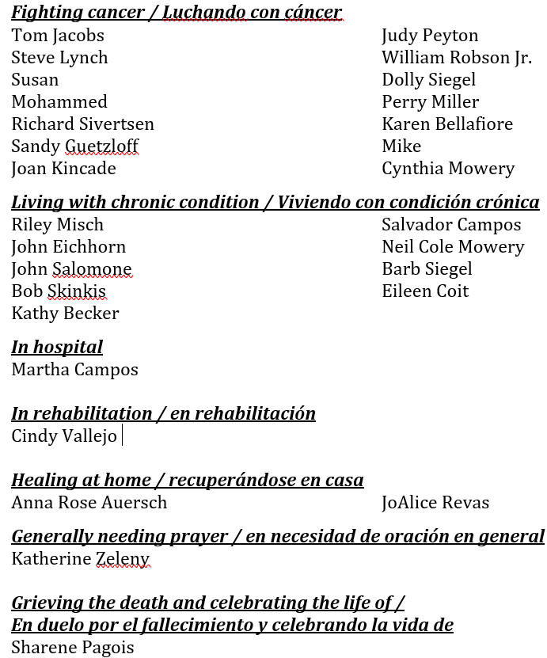

7

Happy Birthday!
¡Feliz Cumpleaños!
Katherine Zeleny December 11th
Cindy Loszach December 15th
Jenny Cole December 23rd
Wayne Winbum December 28th

Happy Anniversary!
¡feliz aniversario
Kathy and Don Becker December 22nd

Memorials –November
In memory of Sharene Pagois (Nancy Hrebenak, Lois Flood, Cheryl and Keith Schwartz, Anna Rose Auersch)
In memory of Troy Olson (Lois Flood, Nancy Hrebenak)

In memory of Ron and Roberta Lesiak (Robin and Rudy Cortes)

Verses for our Times:
The Savior—yes, the Messiah, the Lord—
has been born tonight in Bethlehem!
(Luke 2:11, The Living Bible)

8

9

