8
The Calvary Chronicle
Share the Gospel – Prepare Disciples –
Serve All in Christ’s Love!
June 2023
Volume 87 - Number 06
La Crónica del Calvario
¡Compartir la palabra – Preparar discípulos – Servir a todos en el amor de Cristo!
Junio 2023
Volumen 87 – Número 06

One Church - One Congregation – One Chronicle
Una iglesia - Una Congregación – Una Crónica
06/04/2023- Trinity Sunday
Genesis 1:1-2:4 Ps. 8 2 Corinthians 13:11-13 Matthew 28:16-20
06/11/2023- Second Sunday after Pentecost
Hosea 5:15-6:6 Ps. 50:7-15 Romans 4:13-25 Matthew 9:9-13,18-26
06/18/2023- Third Sunday after Pentecost
Exodus 19:2-8 Ps. 100 Romans 5:1-8 Matthew 9:35-10:8
06/25/2023- Fourth Sunday after Pentecost
Jeremiah 20:7-13 Ps. 69:7-10 [11-15] 16-18 Romans 6:1-11 Matthew 10:24-39

Calvary Evangelical Lutheran Church
6149 S. Kenneth Ave. Chicago, IL 60629
(773) 767-7400
Email: calvaryluther@sbcglobal.net
URL: chicagolutheran.org
facebook.com/chicagolutheran.org

1

From the Pastor’s Desk- June 2023
The first Christian Pentecost, ten days after Jesus’s ascension, radically disrupted the plans, actions, and understandings of Jesus’s disciples. The Holy Spirit interrupted the “normal” gathering that celebrated the Jewish festival that marked the giving of the Law to Israel and an ancient commemoration of the harvest. Neither the apostles nor the others who were present had expected that Christ’s promise that they would be filled with the Holy Spirit would be fulfilled in the way that it was, with the sound of wind, tongues of fire, and a myriad of languages telling the Gospel to people from all over the known world. It was integral to Jesus’s followers being able to continue Jesus’s mission; it was part of God’s plan; it was a foundational event for the future of the Church. Nevertheless, probably no one was comfortable with the situation. No one knew exactly what to do or what would come next.
In our continuing to move forward following the COVID-19 pandemic, we also don’t know exactly what to do or what will come next. Some things that used to be “normal” will never be the same as before. Many people are uncomfortable—uncomfortable with dwindled attendance in churches, debates over whether or not to continue to livestream worship services, uncertain standards or metrics for church membership or participation, and the significant decrease in the part of the population who identifies with a religious tradition or who attends church regularly.
Pentecost should remind us that our current situation isn’t new. The Church has been here before; as a matter of fact, that’s exactly where it started. Jesus’s first followers allowed the Holy Spirit to lead them in new directions. They gave up (not necessarily eagerly; perhaps because they had no choice) their previous conceptions and patterns. They shared the Good News of Jesus even though some people thought they were drunk or crazy, rejected it, or made fun of them. They made sacrifices, gave up the “normal”, and were uncomfortable—and the Church grew and lived out its mission.
What about us?
Pastor Cox
2
Words of Celebration
Morgan Cortes graduated from Joliet Jr. College with her Associates in Health Information Management Technology and Certificate for Medical Coding Specialist. She is also a Member of the National Society of Leadership and Success.

Sharing Faith Stories
Can you share a faith story from your life? It might be a powerful experience of God in our lives, how you first came to faith in Christ or renewed your faith, a challenging time after which you realized that others’ prayers and God’s mercy helped you through it, why you feel uplifted at worship, how you feel strengthened or calmed through prayer or a hymn or a Bible verse, or other ways in which your faith in Christ or participation in a Christian congregation has been significant in your life. Please either write, type, or email a submission to Pastor Cox or to the church office, or feel free to discuss a possible story with him beforehand.
Let’s share the good news!

Calvary Seniors
Calvary Seniors will meet on Tuesday, June 20, 2023 at 12:00 p.m. Please join the group! Please contact Elaine Lebron or JoAlice Revas with questions or to RSVP.

Bible Study
In adult Christian education, we plan to have our remaining sessions on the book of Acts on June 6 and June 13, then break for the summer. Anyone is welcome; it’s not necessary to have attended the previous sessions. John Whennen and I have begun to discuss possible topics for the fall Bible study or adult forum.

Pastor Cox

3

Thank you again to our Anniversary Task Force and everyone who participated in this momentous occasion!
4

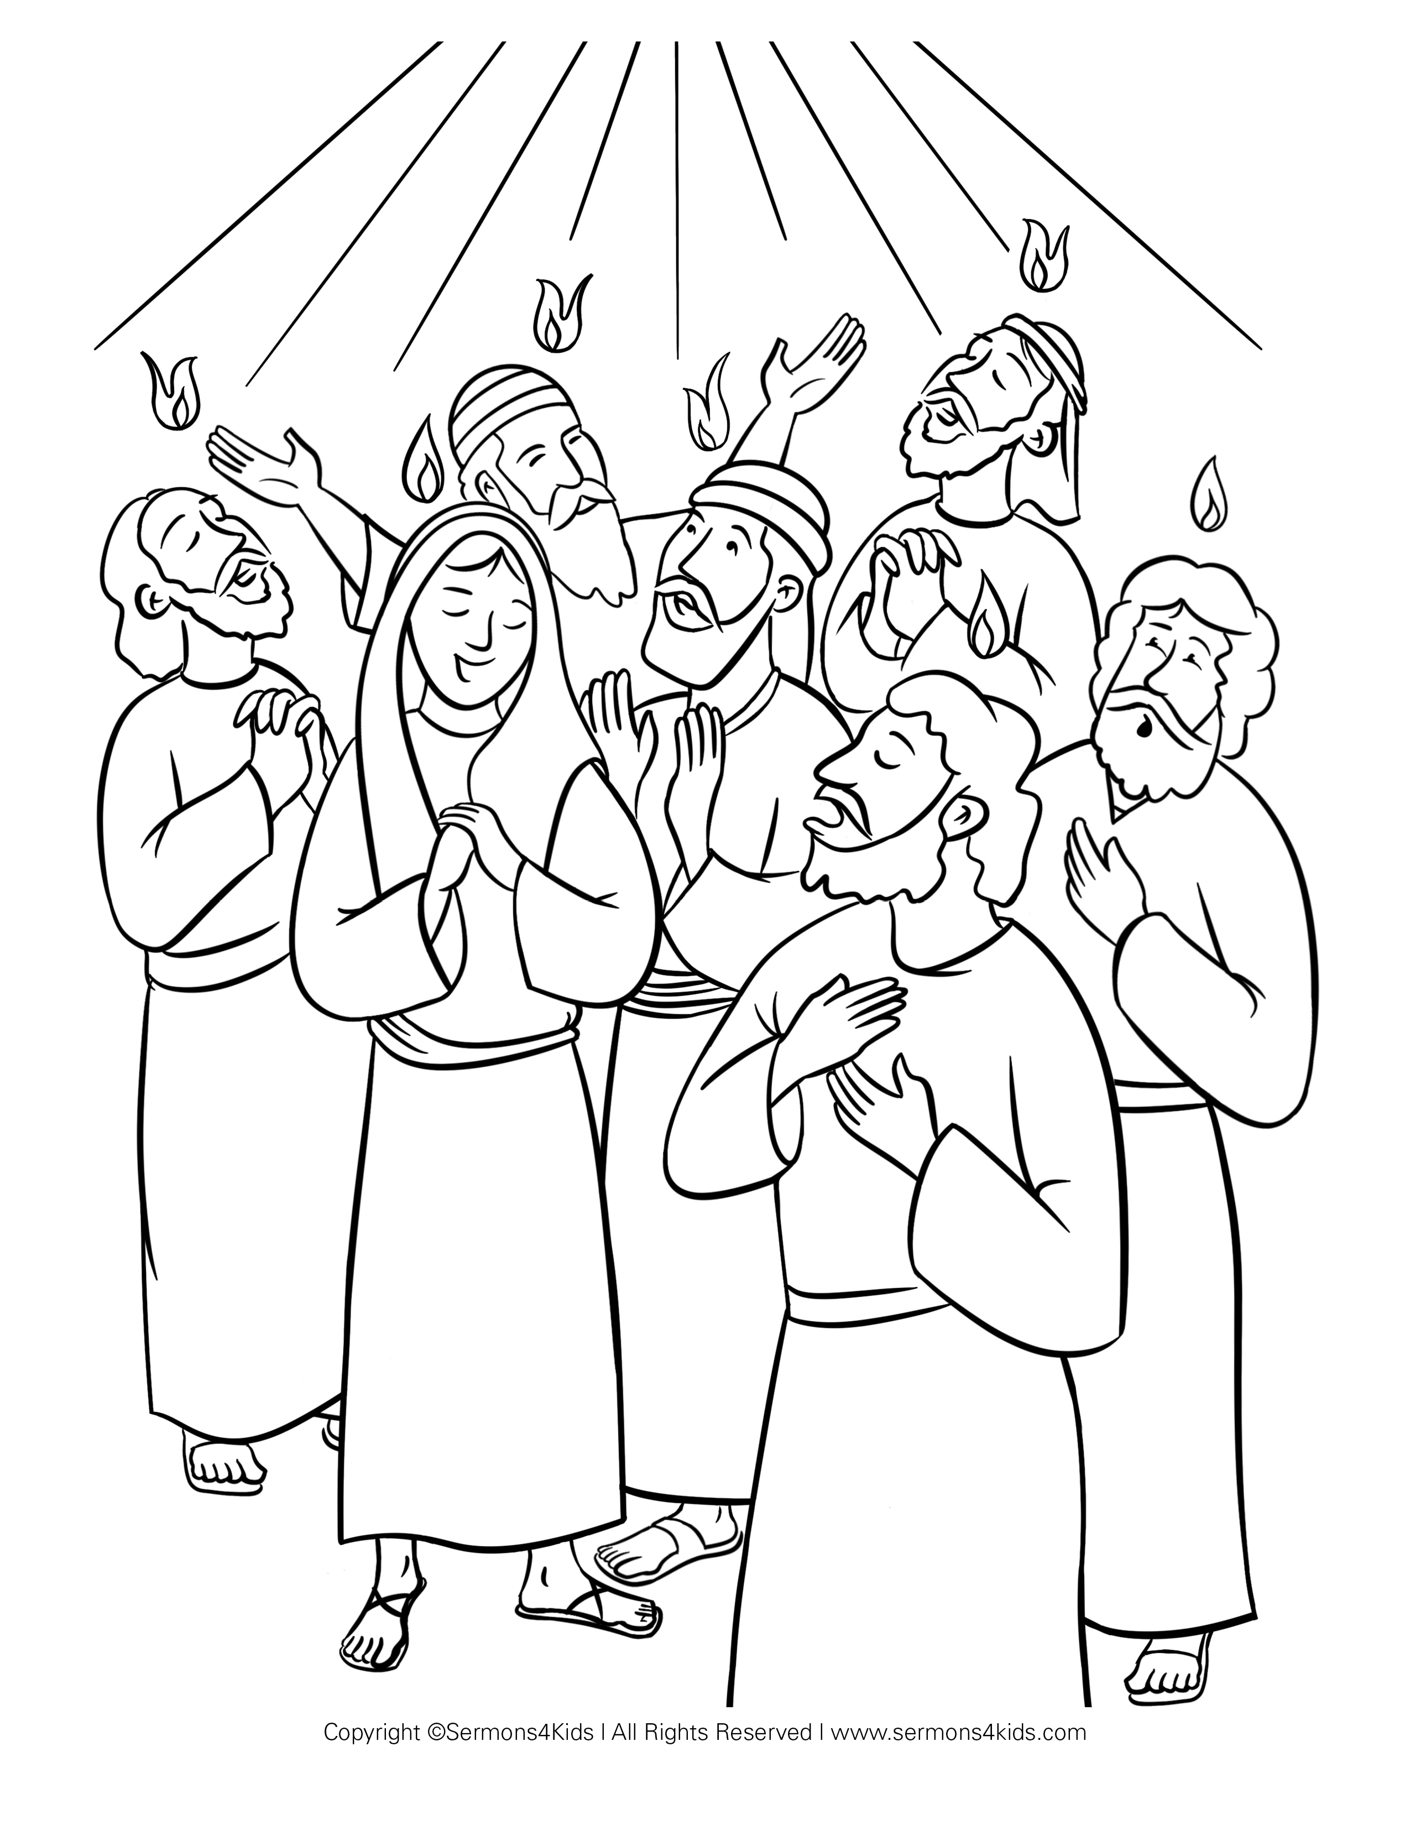
5
6

Happy Birthday!
¡Feliz Cumpleaños!
Joselyn Cortes June 10th

Happy Anniversary!
¡feliz aniversario!
Lois and Jim Flood June 26th

Memorials - June
In Honor of Joselyn Cortes 24th Birthday
Flowers in honor of Lois and Jim Wedding Anniversary
In Memory of Georgianna Sawallisch (Scott Sawallisch)
In Memory of John Vanecek (Anna Rose Aursch)
In Memory of Frances Niemann (Nancy Hrebenak)

Verses for our Times:
The four living creatures and the twenty-four elders
fell down before the Lamb, each holding a harp,
and golden bowls full of incense, which are the prayers of the saints.
9 And they sang a new song, saying,
“Worthy are you to take the scroll
and to open its seals,
for you were slain,
and by your blood you ransomed people for God
from every tribe and language and people and nation,
10 and you have made them a kingdom and priests to our God,
and they shall reign on the earth.”

(Revelation 5:7-13,
English Standard Version)

7
8

