8
The Calvary Chronicle
Share the Gospel – Prepare Disciples –
Serve All in Christ’s Love!
March 2024
Volume 88 – Number 03
La Crónica del Calvario
¡Compartir la palabra – Preparar discípulos – Servir a todos en el amor de Cristo!
Marzo 2024
Volumen 88 – Número 03

One Church - One Congregation – One Chronicle
Una iglesia - Una Congregación – Una Crónica
03/03/2024- Third Sunday in Lent
Exodus 20:1-17 Ps. 19 1st Corinthians 1:18-25 John 2:13-22
03/10/2024- Fourth Sunday in Lent
Numbers 21:4-9 Ps. 107:1-3, 17-22 Ephesians 2:1-10 John 3:14-21
03/17/2024- Fifth Sunday in Lent
Jeremiah 31:31-34 Ps. 51:1-12 Hebrews 5:5-10 John 12:20-33
03/24/2024- Palm Sunday
Isaiah 50:4-9 Ps. 31:9-16 Philippians 31:9-16 Mark 14:1-15:47
03/28/2024- Maundy Thursday
Exodus 12:1-14 Ps. 116:1-2, 12-19 1st Corinthians 11:23-26 John 13:1-17, 31-35

03/29/2024- Good Friday
Isaiah 52: 13-53 Ps. 22 Hebrews 4:14-16; 5:7-9 John 18:1-19

03/31/2024- Easter
Acts 10:34-43 Ps. 118:1-2,14-24 1st Corinthians 15:1-11 Mark 16:1-8

Calvary Evangelical Lutheran Church
6149 S. Kenneth Ave. Chicago, IL 60629
(773) 767-7400
Email: calvaryluther@sbcglobal.net
URL: chicagolutheran.org
facebook.com/chicagolutheran.org

1

From the Pastor’s Desk- March 2024
³⁻⁵ “Why do you look at the speck of sawdust in your brother’s eye and fail to notice the plank in your own? How can you say to your brother, ‘Let me get the speck out of your eye’, when there is a plank in your own? You fraud! Take the plank out of your own eye first, and then you can see clearly enough to remove your brother’s speck of dust.” (Matthew 7:3-5, J.B. Phillips New Testament, 1972)
“ ²Wash me thoroughly from mine iniquity, and cleanse me from mine sin. ³For I know mine iniquities, and my sin is ever before me.” (Psalm 51:2-3, 1599 Geneva Bible)

I admit that I’m pretty cynical about partisan politics. I think many partisan political campaigns bring out the worst in our fallen human nature. Perhaps the biggest example is that candidates for major office, or their campaign managers, do the exact opposite of what God tells us to do regarding our conception of ourselves and others. Campaigns are usually the epitome of what Jesus told his followers not to do in Matthew 7:3-5, cited above. They try to discover, publicize, and amplify every flaw, error, failed policy, and “speck of sawdust” from their opponent’s personal and professional past, while ignoring, denying, or downplaying the flaws, errors, failed policies, and “planks” or logs from their own past. Pardon my cynicism, but it seems to me that often the political candidates and officials who become the most popular and get the most publicity are those who never admit to ever doing or saying anything wrong. We have entered primary election season in a major election year, and hypocrisy is rampant.
That is precisely the opposite of what God tells us to do. The prophet Nathan pointed out King David’s sins of adultery with Bathsheba, abuse of power, and causing Bathsheba’s husband Uriah to be killed in battle. David was a political leader with moral failures. However, at least he, when confronted by the prophet Nathan, acknowledged his sin and repented, as indicated in David’s words cited above (Psalm 51:2-3, which we prayed on Ash Wednesday and will say again on the Fifth Sunday of Lent, March 17, this year).
We all are sinners. Always, but especially during Lent, God wants us to acknowledge our own sin, rather than ignoring it while we publicize the faults of others. As Christians, let us try to avoid following the example of too many politicians. Let us instead eschew hypocrisy and embrace humility, so that we may be more grateful for the forgiveness and mercy that God offers us through Jesus Christ, our Savior and Lord.

With gratitude for God’s great mercy,
Pastor Cox 2
2024 Annual Congregational Meeting Summary
On Sunday, January 28, 2024, Calvary had its annual congregational meeting, after the Sunday worship service. The meeting was held after February Chronicle went to press, so major points of the meeting are summarized here. (Members can also request complete minutes and the report booklet from Secretary Morgan Cortes or Pastor Cox).
17 voting members (which was a quorum) plus four guests and Pastor Cox attended. The meeting began by praying a litany and singing the hymn “Son of God, Eternal Savior.”
The 2023 reports were read and approved. Minutes of the congregational meetings from the previous twelve months were amended slightly and approved. Pastor Cox explained the 2023 congregation report that was printed for review and will be submitted to the ELCA.
The congregation voted to change the constitution section C12.01, “The membership of the Congregation Council shall consist of the pastor and 10 voting members of the congregation” to “…5 voting members….” This was the second vote, as required for constitutional changes; the first vote passed at a special congregational meeting on January 14. The change will become effective following approval by the synod.
The 2024 budget was approved. It projects income of $66,040 and expenses of $124,884, for a deficit of ($58,844). Treasurer Cheryl Schwartz indicated the seriousness of the large deficit and its implications for Calvary’s future. The 2023 deficit given was $32,234, not including an additional $83,034 deficit specific to the roof expenses.
The congregation voted to approve $5,000 for a new boiler pump to address recent concerns about the heat not working as it is programmed to do.
Due to the reduced number of council seats, there was only one open seat. Don Becker and Morgan Cortes had been nominated; Morgan received the majority of votes. Pastor thanked Don Becker, Rudy Cortes Sr., Janice Holstein, Cheryl Schwartz, and John Whennen, who were ending their terms, for having served on the council in the past year.

3
Souper Bowl of Caring
Calvary again participated in the Souper Bowl of Caring on Super Bowl Sunday on February 11, 2024 and the following two Sundays. Several people made a donation into the “soup bowl” that our young adults had following the Sunday worship services. In January, Calvary’s council voted to donate the proceeds to the Greater Chicago Food Depository. We plan to report the total donated in the April Chronicle. Thanks to all who donated to help fight hunger!

Ash Wednesday, Bible Study/Adult Forum, and Lenten Services
During Lent, from February 21 through March 20, we are meeting weekly on Wednesdays for Bible study/adult forum at 10:00 a.m. and a short Lenten service at 11:30 a.m. All are welcome to the study and/or the Lenten service!
We are reading Making Sense of Scripture by David J. Lose, professor of preaching and academic dean at Luther Seminary in St. Paul. We are exploring questions such as “Is the Bible true? How is it the Word of God? Where did it come from? How can I read it with greater understanding? What kind of authority does it hold?” It isn’t necessary to purchase the book in order to attend; we have a few copies to use.

Calvary Seniors
The next Calvary Seniors meeting will be Tuesday, March 19, 2024 at 12:00 p.m. Meetings are usually the third Tuesday of the month at noon. Please contact Elaine Lebron or JoAlice Revas for more information.

Chronicle Deadline
The deadline for submissions to the Calvary Chronicle is normally two Sundays before the end of the month. The deadline for the April 2024 issue will be Palm Sunday, March 24, or speak to Morgan Cortes if you need an extra day or two. The April issue will be distributed in person on Easter Sunday, March 31, or sent via U.S. mail or email to those who receive it in those formats.

4
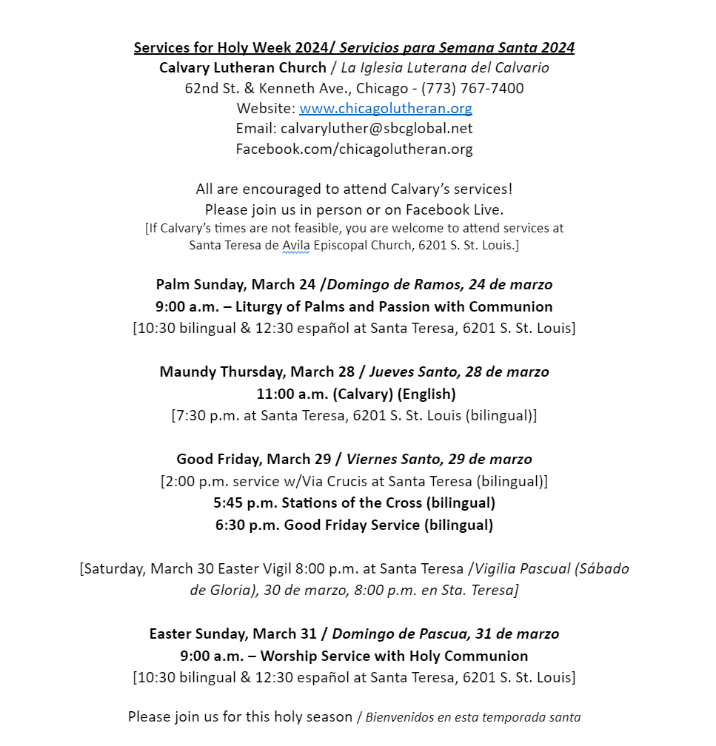
5
6

Happy Birthday!
¡Feliz Cumpleaños!
Rudy Cortes Sr. March 6th
Br. Jamison Wheeler March 6th
Kathy Becker March 23rd
Anna Rose Auersch March 29th
Bryanne Misch March 31st

Happy Anniversary!
¡feliz aniversario!

Memorials – March
In Honor of Rudy Cortes Birthday (Morgan Cortes)
In Memory of Glenn and Mildred Jacobs (Nancy Hrebenak)
In Memory of Fred Hrebenak (Nancy Hrebenak)
In Memory of Frances Niemann (Nancy Hrebenak)
Verse for our Times
¹² The Lord said:
It isn't too late.
You can still return to me
with all your heart.
Start crying and mourning!
Go without eating.
¹³ Don't rip your clothes
to show your sorrow.
Instead, turn back to me
with broken hearts.
I am merciful, kind, and caring.
I don't easily lose my temper,
and I don't like to punish.
(Joel 2:12-13,
Contemporary English Version;
alternate reading for Ash Wed.)

7

8

