8
The Calvary Chronicle
Share the Gospel – Prepare Disciples –
Serve All in Christ’s Love!
April 2024
Volume 88 – Number 04
La Crónica del Calvario
¡Compartir la palabra – Preparar discípulos – Servir a todos en el amor de Cristo!
Abril 2024
Volumen 88 – Número 04

One Church - One Congregation – One Chronicle
Una iglesia - Una Congregación – Una Crónica
04/07/2024- Second Sunday of Easter
Acts 4:32-35 Ps. 133 1John 1:1-2:2 John 20:19-31
04/14/2024- Third Sunday of Easter
Acts 3:12-19 Ps. 4 1John 3:1-7 Luke 24:36-48
04/21/2024- Fourth Sunday of Easter
Acts 4:5-12 Ps. 23 1John 3:16-24 John 10:11-18
04/28/2024- Fifth Sunday of Easter
Acts 8:26-40 Ps. 22:25-31 1John 4:7-21 John 15:1-8

Calvary Evangelical Lutheran Church
6149 S. Kenneth Ave. Chicago, IL 60629
(773) 767-7400
Email: calvaryluther@sbcglobal.net
URL: chicagolutheran.org
facebook.com/chicagolutheran.org

1

From the Pastor’s Desk- April 2024
[Jesus said,] “Very truly, I tell you, unless a grain of wheat falls into the earth and dies, it remains just a single grain; but if it dies, it bears much fruit.” (John 12:24, NRSV)
According to weather reports, we just experienced the warmest February on record in Chicago and several regions of the United States. The winter overall had far less cold and snow that average, though it didn’t break a record. The El Niño weather cycle, climate change, and natural variations from year to year are likely contributors to the mild winter. Although Easter Sunday this year is the last day of March, we have already had numerous days of springlike weather.
Christians in the northern hemisphere often associate Easter with spring. The coincidence of the two times in the calendar is nice and may help relate the theological and the meteorological aspects. Just as Jesus comes back to life, emerging from the tomb after having died and been buried, plants sprout out of the cold, dark earth and make their life visible to us. Jesus himself made a related comparison, which we heard in the Gospel on the Fifth Sunday of Lent—a grain of wheat dying in the earth before it bears fruit (John 12:24, above).
Hymnwriter John Crum (1872-1958) elaborated on this theme in the hymn, “Now the Green Blade Rises” (LBW 148, ELW 379):

Now the green blade rises from the buried grain,
Wheat that in dark earth many days has lain;
Love lives again, that with the dead has been;
Love is come again like wheat arising green.

In the grave they laid him, love by hatred slain,
Thinking that he would never wake again,
Laid in the earth like grain that sleeps unseen;
Love is come again like wheat arising green.

Forth he came at Easter, like the risen grain,
He that for three days in the grave had lain;
Raised from the dead, my living lord is seen;
Love is come again like wheat arising green.
(Text by John Crum, © Oxford University Press)
2

The association of Easter and spring is not universal among Christians, however. I lived in South America for two years as a young adult. Tropical regions lack winter as the United States experiences it, and in the southern parts of South America, the seasons are the reverse of those in the United States.
Nevertheless, for Christians everywhere, whether it is winter or summer, we celebrate the resurrection of our Lord as a bedrock of our faith. Because Jesus has risen from the dead, he has defeated the power of sin and death. Through his resurrection, Christ gives us hope regardless of the climate or weather, and he offers us eternal life which transcends all human calendars and earthly seasons.

In the peace of our risen Savior,
Pastor Cox

3
2024 Leadership
After elections at Calvary’s annual congregational meeting on Sunday, January 28, 2024 and appointments at the congregation council meeting on February 17, the following people are serving as our official leaders of Calvary Lutheran Church for the coming year. Please ask any question of the appropriate person and pray for our leaders and all those involved in our church activities.
President & Pastor the Rev. Gary Cox
Vice President Gina Misch
Treasurer Cheryl Schwartz
Secretary Morgan Cortes

Council Members Nancy Borsellino, Morgan Cortes,
John Ma, Dan Misch, Gina Misch

Minister of Music Brother Jamison Wheeler
Altar Care Anna Rose Auersch
Financial Secretary Nancy Hrebenak
Audit Committee Barb Siegel, Nancy Hrebenak, Janice Holstein, Dan Misch
Mutual Ministry Pastor Cox, Gina Misch, Cheryl Schwartz, John Whennen

Souper Bowl of Caring
Calvary again participated in the Souper Bowl of Caring on Super Bowl Sunday on February 11, 2024 and the following two Sundays. Several people made a donation into the “soup bowl” that our young adults had following the Sunday worship services. We raised $145 for the Greater Chicago Food Depository. Thanks to all who donated to help fight hunger!

Calvary Seniors
The next Calvary Seniors meeting will be Tuesday, April 17, 2024 at 12:00 p.m. Meetings are usually the third Tuesday of the month at noon. Please contact Elaine Lebron or JoAlice Revas for more information.

4

LSSI Presentation; Birthday Celebration
On the Second Sunday of Easter, April 7, 2024, we will welcome a sermon and information by Pastor Kelly Nieman Anderson of LSSI, Lutheran Social Services of Illinois. Rev. Kelly Nieman Anderson is an experienced educator, youth minister, and ordained pastor in the Evangelical Lutheran Church in America. As the Manager of Church and Community Engagement for Lutheran Social Services of Illinois, Pastor Kelly is passionate about sharing God’s healing, justice, and wholeness with everyone she meets. She first learned about LSS’ vision and mission after becoming a licensed foster parent, and has since been connected to their work in multiple states. When she’s not traveling for business, she’s traveling for fun, often with her husband, and normally in an electric car, bicycle, or motorcycle, to try new food or visit their nieces and nephews, and then coming home to relax with their rescue cats.
We’ll learn more about LSSI that day. Calvary has supported LSSI at various times for many years, including with a portion of our 100th anniversary service offering last year. There will be an opportunity to make a donation to LSSI during Pastor Kelly’s visit or afterwards.
Also on April 7, during Coffee And, we will be celebrating Bob Pearson’s 99th birthday with special treats. Please plan to stay if possible to celebrate Bob and to enjoy fellowship after fasting from Coffee And during Lent!
Please plan to attend our worship service and Coffee And on April 7!

Bible Study/Adult Forum
During Lent in our Bible study, we’ve been reading Making Sense of Scripture by David J. Lose, professor of preaching and academic dean at Luther Seminary in St. Paul. The study explores questions such as “Is the Bible true? How is it the Word of God? Where did it come from? How can I read it with greater understanding? What kind of authority does it hold?”
We will finish this book during the Easter season, during the Bible study on the second and fourth Wednesdays of April (April 10 and 24) at 10AM. It isn’t necessary to purchase the book in order to attend; we have a few copies to use. Anyone is welcome to these final sessions.

Chronicle Deadline
The deadline for submissions to the Calvary Chronicle is normally two Sundays before the end of the month. The deadline for the May 2024 issue will be Sunday, April 21, or speak to Morgan Cortes if you need an extra day or two. The May issue will be distributed in person on Sunday, May 28, or sent via U.S. mail or email to those who receive it in those formats.

5

Building and Property News
Parking Lot, Maintenance, & Spring Cleaning
As you know our Parking Lot is in dire need of POTHOLE repairs. A year or so ago I looked into resurfacing the parking lot with blacktop, those bids came in upwards of $40,000.00, an expense we just can't incur as our roof replacement exceeded $100,00.00. I am reaching out because I do not have any contacts in this area of construction. If anyone knows of a contractor who caries liability insurance who can do the patch work please call or email me the info and who is referring them and I will handle it from there.
Next, I truly appreciate those of you who have offered to help me with maintenance in whatever form. As you you know I have declined but only because I needed to give it some thought and had much more pressing issues to deal with first, the HEAT and ROOF. After some thought and council on the subject I decided to do a "Spring Cleaning" event which would cover the church, building and church grounds/property(outside).
Due to varying work schedules and groups utilizing church at different times & days I thought I would create a signup sheet of tasks for anyone or group/team to sign up for with the goal of completion before June and the summer heat hits. In the next few weeks I will post & email a list of tasks if anyone is interested in helping.
I will also be asking the other groups who use the building to help as well.
If you have any questions or concerns please do not hesitate to reach out.

Thank you for your time,
Gina Misch
(312)206-9480
dgmisch95@sbcglobal.net
Calvary Luth Church VP & Property Chair

Handicapped Parking
Please note that as of early 2024, there is a handicapped parking space on 62nd St. directly in front of the (narthex) doors. A current, valid handicapped placard is required to be displayed in order to park there.
6
Archives Temporary Relocation; Call for Volunteers
As mentioned at recent congregational meetings, heavy rains last summer and an old roof on the office/program building resulted in the need to replace the roof and to remove asbestos tile in the archives room, which experienced water damage. The roof replacement was completed by December 2023, but the asbestos removal is scheduled for the end of April. We need volunteers to help move almost all items out of the archives room into another location in the building. We plan to do most of this work on Sunday, April 21, after the Sunday worship service. Some but not all help requires heavy lifting. Please speak to Gina Misch if you are able to help for an hour or two that day or at another time.

101st Anniversary: Save the Date
On Sunday, September 8, 2024, we will welcome Bishop Yehiel Curry, bishop of our Metropolitan Chicago Synod or the Evangelical Lutheran Church in America. We’ll use this occasion to celebrate our 101st anniversary as a congregation. Our big centennial celebration was last year, and this year’s commemoration won’t be as elaborate, but we will do our best to make it a joyous occasion. Though Calvary’s official anniversary date is April 25, we’re postponing our celebration to September so that Bishop Curry can be with us, so we have time to plan, and so we will have completed major maintenance projects, (roof, asbestos, etc.). Please save the date and plan to join us if possible; more information will be shared in the months ahead.

7
8

Happy Birthday!
¡Feliz Cumpleaños!
Bob Pearson April 8th
Salvador Campos April 23rd

Happy Anniversary!
¡feliz aniversario!

Memorials – April
Candle in memory of Carl Auersch (Anna Rose Auersch)
In memory of loved ones (Misch Family)
In memory of Joseph Lupnacca (Anna Rose Auersch)
In memory of Virgina Cole (Cheryl and Keith Schwartz, Nancy Borsellino, Lois Flood, Cortes Family, Nancy Hrebenak, Barb Siegel, Janice Holstein, Anna Rose Auersch, Family of Virgina Cole, Cheryl Tumaitis, Katie Goberling, Roger Tobolt, Tom Mowery, Terry and Stephen Stabine, Jeff and Ann Brandt, KKP Group Terri Flores)

Verse for our Times
⁵ So [the women] went into the sepulcher
and saw a young man sitting at the right side,
clothed in a long white robe.
And they were awestruck.
⁶ But he said to them,
“Do not be so troubled.
You seek Jesus of Nazareth,
Who was crucified.
He is risen.
(Mark 16:5-6b,
Revised Geneva Translation)

9



10
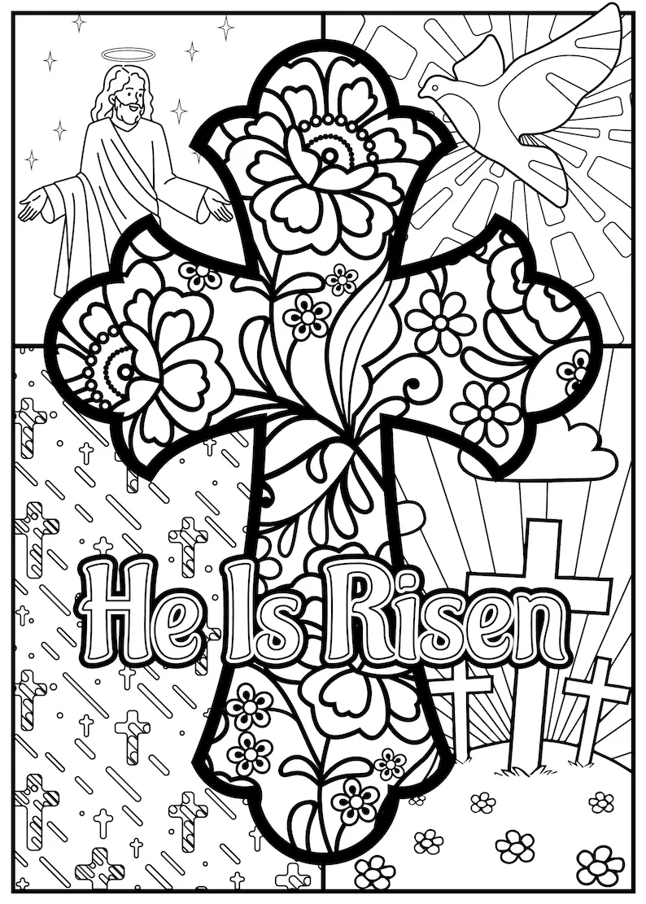

11

12

