8
The Calvary Chronicle
Share the Gospel – Prepare Disciples –
Serve All in Christ’s Love!
January 2025
Volume 89– Number 01
La Crónica del Calvario
¡Compartir la palabra – Preparar discípulos – Servir a todos en el amor de Cristo!
enero 2025
Volumen 89 – Número 01

One Church - One Congregation – One Chronicle
Una iglesia - Una Congregación – Una Crónica
01/05/2025- Second Sunday after Christmas
Jeremiah 31:7-14 Ps. 147:12-20 Ephesians 1:3-14 John 1:1-18
01/06/2025- The Epiphany
Isaiah 60:1-6 Ps. 72:1-7,10-14 Ephesians 3:1-12 Matthrew 2:1-12
01/12/2025- First Sunday after the Epiphany
Isaiah 43:1-7 Ps. 29 Acts 8:14-17 Luke 3:15-17,21-22
01/19/2025- Second Sunday after the Epiphany
Isaiah 62:1-5 Ps. 36:5-10 1st Corinthians 12:1-11 John 2:1-11
01/26/2025- Third Sunday after the Epiphany
Nehemiah 8:1-3,5-6, 8-10 Ps. 19 1st Corinthians 12:12-31 Luke 4:14-21

Calvary Evangelical Lutheran Church
6149 S. Kenneth Ave. Chicago, IL 60629
(773) 767-7400
Email: calvaryluther@sbcglobal.net
URL: chicagolutheran.org
facebook.com/chicagolutheran.org

1

From the Pastor’s Desk-January 2025

2
Bible Study/Adult Forum
In fall and Advent 2024, we began studying the Gospel according to Matthew, and we hope to continue to study Matthew through the first half of 2025. We are considering spending ten to fifteen minutes in intercessory prayer at each session, in addition to the Bible study.
Our next Bible study/adult forum sessions are planned for Tuesday, January 14 and Tuesday, January 28, 2025 at 10:00 a.m. Attendance has been sparse at recent sessions. Please RSVP to John Whennen or Pastor Cox if you plan to attend, or if you previously announced plans to attend but your plans change, to plan accordingly.
Souper Bowl of Caring
Calvary will again participate in the Souper Bowl of Caring on Super Bowl Sunday on February 9, 2025. Everyone is invited to make a donation into the “soup bowl” our young adults will have that Sunday following the worship service. If unable to attend worship that Sunday, you may donate the preceding or the following Sunday in an envelope marked “Souper Bowl of Caring.” Proceeds go to fight hunger; in recent years, they were distributed between the Greater Chicago Food Depository and ELCA World Hunger.
Calvary Seniors
There will not be a Calvary Seniors Meeting in January. Meetings are usually the third Tuesday of the month. Please contact Elaine Lebron or JoAlice Revas for more information.
Chronicle Deadline
The deadline for submissions to the Calvary Chronicle is normally two Sundays before the end of the month. The deadline for the February 2025 issue will be Sunday, January 19, or speak to Morgan Cortes if you need an extra day or two. The February issue will be distributed at the annual meeting on January 26 or sent via U.S. mail or email to those who receive it in those formats.

3

4
Congregation Council Elections
The current roster of voting members of Calvary’s congregation council are:
Member name: term expires in January of:
Nancy Borsellino 2025 (prior to this term, completed 2nd year of another
member’s term, so not eligible for immediate reelection)
Morgan Cortes 2026 (2nd, not eligible for reelection)
John Ma 2025 (2nd, not eligible for reelection)
Dan Misch 2025 (1st, eligible for reelection)
Gina Misch 2025 (2nd, not eligible for reelection)

In addition, Pastor Cox and Cheryl Schwartz attend council meetings as non-voting members (president and treasurer, respectively). As the above list indicates, Nancy Borsellino, John Ma, and Gina Misch will have their terms end next month and are not eligible for reelection. Dan Misch’s term also ends, but he is eligible for reelection. We encourage voting members to consider running for congregation council. Calvary has fewer members and a smaller council; everyone’s input, collaboration, and ideas are important as we discuss and make important decisions about our life and ministry.

5

Prayer List Reminder
In 2022, Calvary’s council voted to update our practices regarding the prayer list. Since June 2022, the prayer list published in the Chronicle retains the names of those for whom we pray for one month, except those with cancer or another long-term condition are retained for six months. If you know that someone is still in need of prayer after those times, please re-submit his or her name to Morgan Cortes or Pastor Cox before the next Chronicle deadline. This helps to keep our list and records current and to hear how people are doing on a periodic basis.
Everyone is encouraged to pray for all those who are on the prayer list and to send a card, note, or email, or call, depending on the person’s condition. If anyone has a more serious or longer-term illness or might like a pastoral visit, please contact Pastor Cox.

6

Happy Birthday! Happy Anniversary!
¡Feliz Cumpleaños! ¡feliz aniversario!
Rachel Becker January 4th
Dylan Scott January 5th

Memorials
In memory of Betty Larkner 100th Birthday (Patty Schab)
In memory of Keith Johnson (Joyce Johnson)

Verses for our Times:
See, darkness covers the earth
and thick darkness is over the peoples,
but the Lord rises upon you
and his glory appears over you.
Isaiah 60:2
[New International Version]

7

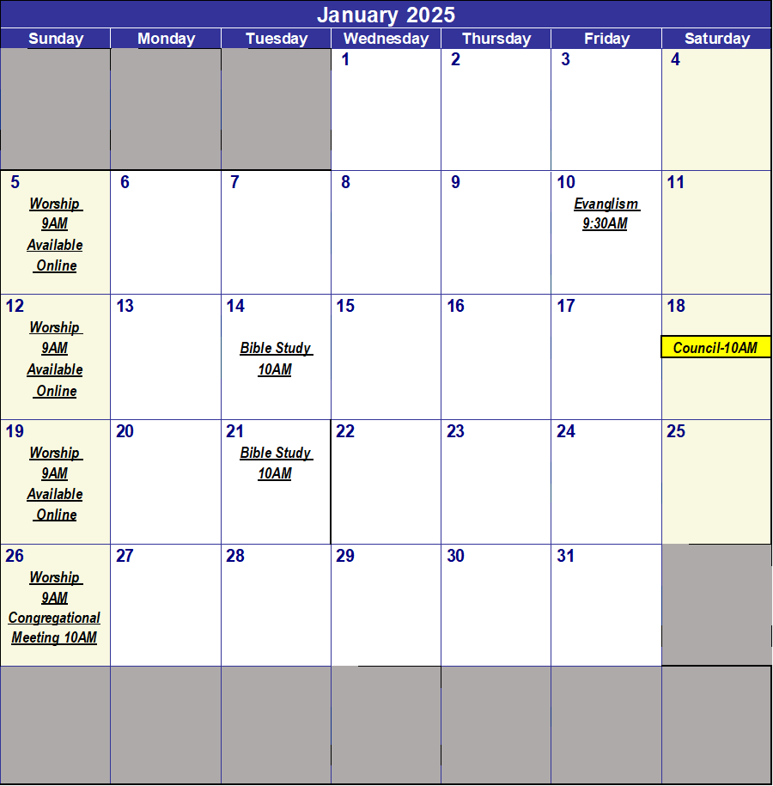

8

