8
The Calvary Chronicle
Share the Gospel – Prepare Disciples –
Serve All in Christ’s Love!
February 2025
Volume 89– Number 02
La Crónica del Calvario
¡Compartir la palabra – Preparar discípulos – Servir a todos en el amor de Cristo!
febrero 2025
Volumen 89 – Número 02

One Church - One Congregation – One Chronicle
Una iglesia - Una Congregación – Una Crónica
02/02/2025- Presentation of Our Lord
Malachi 3:1-4 Ps. 84 Hebrews 2:14-18 Luke 2:22-40
02/09/2025- Fifth Sunday after the Epiphany
Isaiah 6:1-13 Ps. 138 1st Corinthians 15:1-11 Luke 5:1-11
02/16/2025- Sixth Sunday after the Epiphany
Jeremiah 17:5-10 Ps. 1 1st Corinthians 15:12-20 Luke 6:17-26
02/23/2025- Seventh Sunday after the Epiphany
Genesis 45:3-11,15 Ps. 37:1-11, 39-40 1st Corinthians15: 35-38,42-50 Luke 6:27-38

Calvary Evangelical Lutheran Church
6149 S. Kenneth Ave. Chicago, IL 60629
(773) 767-7400
Email: calvaryluther@sbcglobal.net
URL: chicagolutheran.org
facebook.com/chicagolutheran.org

1

From the Pastor’s Desk- February 2025

2

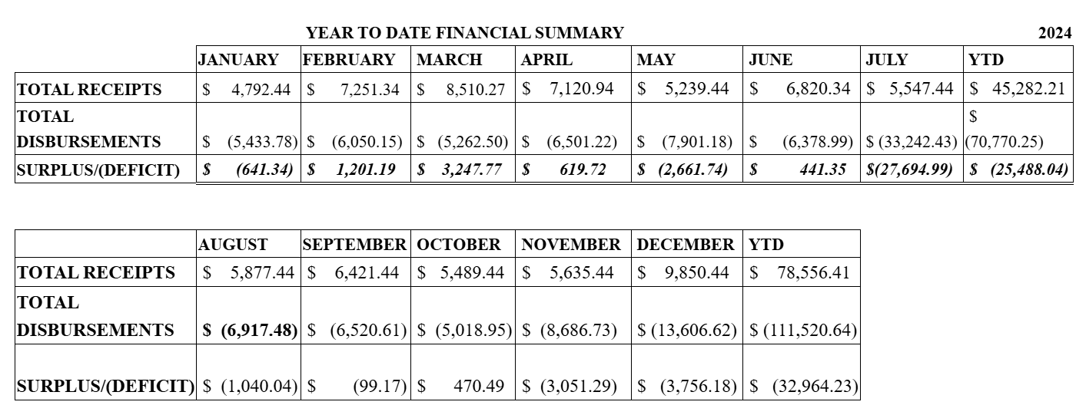
Congregational Meeting
This month’s Chronicle went to press before our annual congregational meeting on January 26, 2025, so the results of the meeting are not yet available. Results of the council member elections and other important news of the meeting will be shared in the March Chronicle issue.

Chicago CROP Hunger Walk Results
The final, year-end figures from the Chicago CROP Hunger Walk held on October 20, 2024 have come in. Calvary walkers, members, and donors raised $1,387, including online donations, cash, and checks. 25% of this amount goes to feeding programs in Chicago; 75% goes to Church World Service for disaster relief, development work, refugee support, and other hunger-related efforts to those in need. Thank you to everyone who walked or sponsored Calvary walkers or the Calvary team.
3
Eco-stewardship: Recycling Project
In fall 2024, Yoan Viamonte proposed an Eco-Stewardship project to Calvary’s Evangelism Committee, which discussed and presented it to council. The policy was presented to council at the January meeting and is being revised following council’s discussion. The first aspect of the project, however, is already underway. Council already approved the placement of recycling containers in various areas of Calvary’s facilities. Plastic bottles or jars,, glass jars, aluminum or other metal cans, and clean paper or cardboard are accepted. Please look for the bins and signs in the narthex, hall, kitchen, and other locations. Let’s be good stewards of God’s creation and reduce, reuse, and recycle to lessen the amount of waste and energy use.
Souper Bowl of Caring
Calvary will again participate in the Souper Bowl of Caring on Super Bowl Sunday on February 9, 2025. Everyone is invited to leave a donation in the “soup bowl” our young adults will have that Sunday following the worship service. If unable to attend worship that Sunday, you may donate the preceding or the following Sunday in an envelope marked “Souper Bowl of Caring.” In January, Calvary’s council voted to donate the proceeds to the Greater Chicago Food Depository. Thank you for your donations to help fight hunger!
Bible Study
In fall and Advent 2025, we began studying the gospel according to Matthew, and we hope to continue to study Matthew through the first half of 2025. We are considering spending ten to fifteen minutes in intercessory prayer to each session, in addition to the Bible Study
Our next Bible study/adult forum sessions are planned for Tuesday, February 11th and Tuesday, February 25th at 10:00 AM. Attendance has been sparse at recent sessions. Please RSVP to John Whennen or Pastor Cox if you plan to attend, or if you previously announced plans to attend but your plans changed, to plan accordingly.

4
Upcoming Events
Easter is later than average this year, so Ash Wednesday isn’t until March 5. We tentatively plan a service at 11:00 a.m. that day.
The Metro Chicago Synod’s Lay Leadership Day will be held Saturday, March 29, 2025 from 9:00 a.m. – 1:30 p.m. at Prince of Peace Lutheran Church in Schaumburg. It includes worship, a guest speaker, and workshops. The cost is $10 to cover lunch. If anyone is interested in attending or for more information, please see the synod’s website www.mcselca.org or ask Pastor Cox.
Saturday, May 30-31, 2025 will be our synod’s annual assembly. It will be held in St. Charles from morning through late afternoon. Workshops on various topics, reports on the synod budget and governance, reports from our bishop and officers, mission moments, worship, and lunch are all included. Calvary is allotted two delegates and pays the all-inclusive registration fees. Please inform Pastor Cox as soon as possible if you would consider attending as a delegate from Calvary this year.


5

6

Happy Birthday! Happy Anniversary!
¡Feliz Cumpleaños! ¡feliz aniversario!
Don Becker February 6th Nancy and Terry Borsellino February 1st
Lois Flood February 12th Larry and Louise Breen February 24th

Memorials
There are no Memorials for February

Verses for our Times:
(Simeon said:)
“Sovereign Lord, as you have promised,
you may now dismiss^{[a]} your servant in peace.
³⁰ For my eyes have seen your salvation,
³¹ which you have prepared in the sight of all nations:
³² a light for revelation to the Gentiles,
and the glory of your people Israel.”

(Luke 2:29-32, New International Version)

7

8

