8
The Calvary Chronicle
Share the Gospel – Prepare Disciples –
Serve All in Christ’s Love!
June 2025
Volume 89– Number 06
La Crónica del Calvario
¡Compartir la palabra – Preparar discípulos – Servir a todos en el amor de Cristo!
junio 2025
Volumen 89 – Número 06

One Church - One Congregation – One Chronicle
Una iglesia - Una Congregación – Una Crónica
06/01/25- Seventh Sunday of Easter
Acts 16:16-34 Ps. 97 Revelation 22:12-21 John 17:20-26
06/08/25- Day of Pentecost
Acts 2:1-21 Ps. 104:24-35 Romans 8:14-17 John 14:8-17 [25-27}
06/15/25- First Sunday after Pentecost & Holy Trinity
Proverbs 8:1-4, 22-31 Ps. 8 Roman 5:1-5 John 16:12-15
06/22/25- Second Sunday after Pentecost
1 Kings 19:1-15 Ps. 22:19-28 Galatians 3:23-29 Luke 8:26-39
06/29/25- Third Sunday after Pentecost
2 Kings 2:1-2,6-14 Ps. 16 Galatians 5: 1, 13-25 Luke 9: 51-62

Calvary Evangelical Lutheran Church
6149 S. Kenneth Ave. Chicago, IL 60629
(773) 767-7400
Email: calvaryluther@sbcglobal.net
URL: chicagolutheran.org
facebook.com/chicagolutheran.org

1

From the Pastor’s Desk- June 2025
While he was blessing them, he withdrew from them and was carried up into heaven. And they worshiped him and returned to Jerusalem with great joy, and they were continually in the temple blessing God. (Luke 24:51-53)
. . .
¹⁰ While he was going and they were gazing up toward heaven, suddenly two men in white robes stood by them. ¹¹ They said, “Men of Galilee, why do you stand looking up toward heaven? This Jesus, who has been taken up from you into heaven, will come in the same way as you saw him go into heaven.”
(Acts 1:10-11)
(both citations are from the New Revised Standard Version Updated Edition [2021])

Ascension Day is forty days after Easter Sunday and ten days before Pentecost, so it always falls on a Thursday. Though officially it’s a major feast day in most liturgical Christian churches, it’s often overlooked. (It just passed a few days ago, on May 29 this year.)
According to the last verse of Luke’s Gospel, after Jesus ascended into heaven, Jesus’s apostles went to Jerusalem “with great joy…continually in the temple blessing God.” However, the first chapter of Acts gives more details. The apostles had still unanswered questions when Jesus returned to heaven, such as if the kingdom was going to be returned to Israel now (Acts 1:6). At the Mount of Olives (1:12), they stared up at the sky as Jesus departed (1:10), then two men (often interpreted as angels) questioned their upward gaze and promised that Jesus would return (1:11). Luke and Acts were both written by the same author, yet the last verses of Luke and the first verses of Acts show us that Jesus’s first followers had a mix of experiences and feelings at Jesus’s Ascension and immediately thereafter.
I think these mixed feelings and thoughts speak to Calvary’s situation and the broader situation of many churches in 2025.
If we’re still practicing Christians who attend and identify with a Christian congregation in 2025, we have probably experienced challenges but also God’s providence, love, and presence. In some sense, we’ve experienced suffering and death, but also resurrection and mountaintop experiences of glory. Jesus himself experienced these human situations in his own Passion, death and resurrection, which form the center of our faith.
Then, however, Jesus left his apostles physically again, this time for good. They were told to wait for the Holy Spirit (Acts 1:4-5), but in the meantime, they had that mix of feelings that I think included uncertainty, gratitude, joy, and the loss of separation.
Likewise, we’re grateful for God’s work in our lives and in our congregations, but five years after Covid-19 began, we have come to realize that the world and the Church have changed. Some things will remain, but other things are never going to go back to the way they were several years or decades ago. Some members who stopped attending during the pandemic or before are never coming back. Some new people come, but significantly less than before. Parents no longer are successful at convincing their young adult children to remain or become church members for the next generation, or perhaps the parents have given up or don’t even try.

2
For the reduced percentage of people who do identify with a congregation or denomination, some are content to watch church services online rather than in person, or to follow its social media feed rather than interact directly with fellow Christians. Religion is seen by many people as a personal belief for one’s spiritual contentment, not an issue of truth or a relationship with the Creator and Redeemer of the world.
So, what do the few of us who are still attending worship and contributing to a Christian community do? We feel grateful for what the Lord has done, yet also bewildered, like the apostles did at Jesus’s ascension. We hear the message that the Lord has not abandoned us. We wait for the Holy Spirit to guide us.
I encourage us all to recall and to reflect on what Jesus’s first followers felt in that in-between time, after their recent experience with their faith changed or ended and before what was coming next was made clear to them. The often-overlooked Ascension of our Lord may be an important key for Calvary and for many other Christians to grapple with the decisions and situations we face in the months and years ahead.

In Christ, our ascended Lord,
Pastor Cox

3

Eco-stewardship: Recycling Project
As part of the Eco-Stewardship project proposed by Yoan Viamonte in 2024, a recycling program was approved by Council and has now been implemented in Calvary’s facilities. Plastic bottles or jars, glass jars, aluminum or other metal cans, and clean paper or cardboard are accepted. Please look for the bins and signs in the narthex, Luther Hall near the kitchen, the church office, and the meeting room. We have a special scale to weigh the materials we recycle and keep data on how much we recycle. Items will be taken to appropriate locations to be recycled.
Joselyn and Morgan Cortes weighed the first round of recyclables, collected roughly from March 15-May 10; they totaled 3.6 pounds (not counting the weight of the blue bins). Maranatha Seventh Day Adventist Church and Alcoholics Anonymous groups are recycling with us, too.
Let’s be good stewards of God’s creation and reduce, reuse, and recycle to lessen the amount of waste and energy use.
Calvary Seniors
Calvary Seniors will meet on Tuesday, June 17 at noon, its regular monthly gathering in Luther Hall on the third Tuesday of the month. Please contact Elaine Lebron for more information.
Bible Study and Intercessory Prayer
Our final adult forum and Bible study of the spring will be on Tuesday, June 3, 2025 at 10AM. We are finishing our study of the Gospel according to Matthew, led by John Whennen. We now include intercessory prayer at the end of each session. All are welcome to attend. We will not meet in July or August but plan to resume in the fall.
Synod Assembly
Saturday, May 30-31, 2025 was our Metropolitan Chicago Synod’s annual assembly. Workshops, reports, mission moments, worship, and an election for bishop were held. This issue of the Chronicle went to press before the assembly, so we will share significant news about it at Sunday worship services in early June and in the July issue of the Chronicle.

4
Three Pathways
Calvary members were invited to a meeting about Three Pathways on Saturday, May 3, 2025, from 10:00 a.m. – 1:00 p.m. Eleven people from Calvary attended as well as Pastor Kathy Nolte and Pastor Karla Thompson-Powell of our Metropolitan Chicago Synod.
Pr. Kathy explained the Three Pathways process, which the Metropolitan Chicago Synod of the ELCA developed to guide congregations that are or may be not sustainable for the future. Attendees introduced themselves and shared how long they had been at Calvary.
As described earlier in congregational meetings, three general pathways for congregations with questionable sustainability are (1) transformation (making major internal changes to connect with God’s mission, with variations of a vitality process, reimagining ministry, or selling the building), (2) community partnership with another congregation (with variations including merger, consolidation, or yoking or anchor parish model), and (3) closure (with variations including reopening as a new mission start or word and service mission post).
Pr. Kathy distributed the Congregational Sustainability Assessment, developed by Sussan Briner of the Southwestern Texas Synod of the ELCA. The introduction to this document states:
“Congregations need resources to sustain ministry. The primary resources include the church facility (in which to conduct ministry), money (to pay staff, fund ministries, and maintain facilities) and people (to engage in ministries). Vital congregations that aren’t sustainable can’t continue God’s mission in their setting. Sustainable congregations that are not vital may be out of touch with God’s mission for them in this time and place.”
The assessment then included specific questions relating to Building and Maintenance (building age and how much it is used), Pastoral Compensation, Finances and Stewardship (including how much giving comes from those over age 65, how much comes from one or two top givers, diversity of forms of giving, and mission support), Leadership (having enough people to serve on council, committees, and ministries), and Worship (having enough people to provide worship, in-person attendance trends). For each of these areas, the assessment asks to summarize whether it is a strength or a weakness. The consensus was that while the current building usage is a strength and we’ve had enough leaders to continue to provide weekly worship, the other areas are overall weaknesses.
Pr. Kathy noted that Calvary has already been doing community partnerships rather well. They have allowed Calvary to continue for several years since the possibility of closing first arose about ten years ago.
5

However, attendance, membership, and financial resources have continued to gradually decline such that closure seems the likely outcome within a couple of years.
Pastor Kathy invited us to have a few moments of silence to reflect on this situation. Afterwards, several questions and comments arose. In the remainder of 2025, It would be premature to have a congregational meeting with a resolution to close, but we can have conversations with the other groups that use Calvary’s facilities to make them aware of our situation, consider visiting a few other congregations in the area, and obtain information on realtors who deal with churches. We also need to decide whether or not to replace the boilers in the original building, which are near the end of their estimated life. To do so would spend a significant portion of our remaining reserves, but new boilers would be more attractive to a buyer.
Many more details will be discussed by leaders in the next several months and shared with members later this year. We tentatively plan to meet again with Pastor Kathy in the fall of 2025.
Pastor Cox
P.S. After the meeting, Pastor Carla gave Pastor Cox a list of congregations within eight miles of Calvary, in reference to a recommendation to get a group together to visit three other congregations that might be suitable should Calvary close. Since summer is rapidly approaching and everyone’s schedule is different, it would be difficult to get a consensus on dates and times, plus the fact that everyone has different logistics on how far they wish to travel to church. Therefore, if anyone is interested in pursuing this, it is recommended that you do this on your own. You can contact the Pastor Cox for the list. Feel free to coordinate with others if you wish to go as a group, but there will not be official coordination of dates and times.
Cheryl Schwartz

6

PENTECOST

7
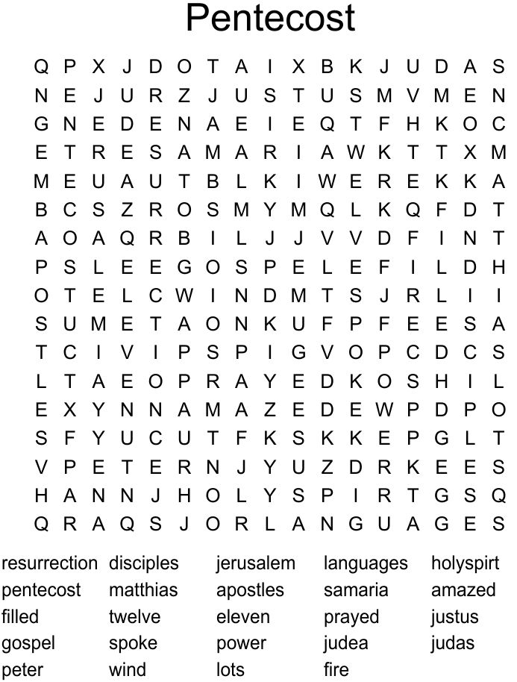

8
HOLY TRINITY
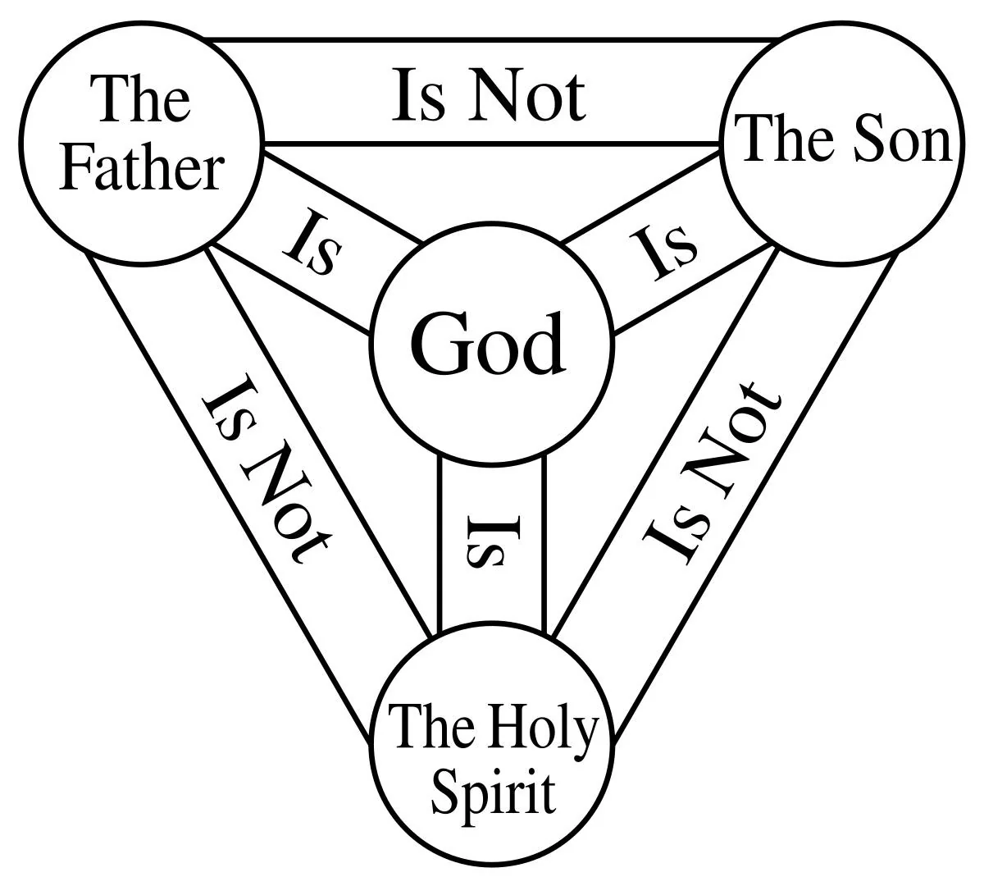
9

10

Happy Birthday! Happy Anniversary!
¡Feliz Cumpleaños! ¡feliz aniversario!
Joselyn Cortes June 10th Jim and Lois Flood June 26th

Memorials
Flowers in honor of Jim & Lois' 60th Wedding Anniversary (Lois Flood)
In honor of Joselyn Cortes Birthday (Cortes Family)
In memory of Bob Pearson (Cortes Family, Nancy and Milan Hrebenak, Cheryl and Keith Schwartz, Lois and Jim Flood)
In memory of Georgianna Sawallisch (Scott Sawallisch)

Verses for our Times:
But you will receive power when the Holy Spirit has come upon you,
and you will be my witnesses in Jerusalem,
in all Judea and Samaria, and to the ends of the earth.”
(Acts 1:8,
New Revised Standard Version,
Updated Edition [2021])

11

12

