8
La Crónica del Calvario
¡Compartir la palabra – Preparar discípulos – Servir a todos en el amor de Cristo!
marzo 2026
Volumen 90 – Número 03
The Calvary Chronicle
Share the Gospel – Prepare Disciples –
Serve All in Christ’s Love!
March 2026
Volume 90– Number 03

One Church - One Congregation – One Chronicle
Una iglesia - Una Congregación – Una Crónica
03/01/26-Second Sunday in Lent
Genesis 12:1-4 Ps. 121 Romans 4:1-5,13-17 John 3:1-17
03/08/26- Third Sunday in Lent
Exodus 17:1-7 Ps. 95 Romans 5:1-11 John 4:5-42
03/15/26- Fourth Sunday in Lent
1 Samuel 16:1-13 Ps.23 Ephesians 5:8-14 John 9:1-41
03/22/26- Fifth Sunday in Lent
Ezekiel 37:1-14 Ps. 130 Romans 8:6-11 John 11:1-45
03/29/26- Palm Sunday
Isaiah 50:4-9 Ps. 31:9-16 Philippians 2:5-11 Matthew 26:14-27:66
Calvary Evangelical Lutheran Church
6149 S. Kenneth Ave. Chicago, IL 60629
(773) 767-7400
Email: calvaryluther@sbcglobal.net
URL: chicagolutheran.org
facebook.com/chicagolutheran.org

1

Pastor’s Column- March 2026
“Jesus began to weep.”
(John 11:35, New Revised Standard Version Updated Edition)

“O Lord, my God, my Savior, by day and night I cry to you.
You have laid me in the depths of the pit, in dark places, in the abyss.”
(Psalm 88:1, 7, Lutheran Book of Worship)

“Some wandered in desert wastes; they found no way to a city where they might dwell.
Then they cried to the Lord in their trouble, and he delivered them from their distress.
He put their feet on a straight path to go to a city where they might dwell.
Let them give thanks to the Lord for his mercy and the wonders he does for his children.”
(Psalm 107:4, 6, 7, 8, Lutheran Book of Worship)

This year in Lent, we may especially feel that we are walking in the wilderness. Disturbing events in this nation and in the world have made many people anxious, wondering when the next aggression will occur, by our government against citizens, residents, or foreign nations, or vice versa, or by other groups or individuals. In addition, several of us have stressful situations that we, family members, or close friends are having to confront. On top of all of that, however, we have entered the final months as a congregation. After the difficult vote on January 25 to close and sell Calvary’s building and grounds, as described in this and last month’s Chronicle, several members have started to ask me about other churches to consider transferring to and/or have begun to more openly share feelings of sadness.
I shared with council at our February meeting that years ago, I experienced the closing of a faith community of which I had been an active member. I hadn’t been there as long as some of you have been at Calvary, but I felt deep attachment and was filled with grief in the final weeks and final worship service. We should be thankful for Calvary’s many years of ministry, but this doesn’t deny the sadness and mourning that many will feel. Grief is not unfaithful; it is healthy and a part of being human. Jesus himself wept at Lazarus’s tomb, as we’ll hear on the Fifth Sunday of Lent, March 22, this month. In fact, John 11:35 was often cited as the shortest verse in the Bible, as the King James Version’s translation (see “Verses for our Times” in this Chronicle) was even shorter than the NRSVUE above.
Likewise, the book of Psalms has many types of poetry (or song lyrics), as we’ll explore a bit in our Bible study this month. One category that we underrepresent in worship are psalms of lament, in which the psalmist pours out the grief, pain, and complaint to God. Their inclusion in Scripture reaffirm that it is not unfaithful or unchristian to express these sentiments openly before God and others.
So, as we continue in our Lenten wilderness journey, let us recognize and accept these feelings of grief, death, and lament, present them to God, and ask God’s grace to heal and continue forward.

Grace and peace,
Pastor Cox

2
Calvary’s Closing Process
Previous Chronicle issues have reported on the meetings with synod staff and congregation members in the past two years having led to the conclusion that Calvary is not sustainable for the long term, the acceptance that holy closure is the only pathway that seems feasible, and the congregation’s vote on January 25, 2026 to close in May and to sell the property to Maranatha Seventh Day Adventist Church, which has had a space use agreement with Calvary since July 2018.
In February, the congregation council discussed and offered a price of $300,000 to Maranatha for the building and property, just under half of the appraised value. The reduced price takes into account our desire that Maranatha not only be able to purchase but also maintain the property, the fact that our synod strongly encourages us to finalize a sale before we close so that it does not need to assume ownership, and the fact that it is very difficult to sell church buildings. Several weeks ago, Maranatha applied for a loan from its denominational structures but already has been raising most of this amount from its members. Both Calvary and Maranatha now need to work with real estate agents and attorneys in order to prepare a complete legal transaction by May 17 if possible.
Maranatha has already taken over several tasks in the property, including cleaning of areas it uses, watering plants in the sanctuary, minor maintenance, and some other tasks. In late January, Gina Misch, our last Property chair, walked through the entire property with several Maranatha leaders, to show them areas they have not seen, including the former Consuelo offices on the third floor, the sexton’s apartment, pastor’s office, etc., including some building concerns.
Council will be discussing and proposing distribution of remaining assets in the next several weeks. Pastor has been in communication with St. Mary Recycle Mission, which receives donations of liturgical items to redistribute to churches in need or churches that have lost items due to fires or natural disasters.
Thanks to Cheryl Schwartz, John Whennen, Rudy and Robin Cortes, and Lois Flood for their help in purging old files. We will need additional help with related tasks; please let Pastor Cox know if you’re willing to help in any way.
One suggestion was to cancel worship at Calvary on a Sunday in March or April to give members a more direct opportunity to visit another church which they may want to join later this year. However, the majority of regular attendees surveyed prefer to either do this after May 17 or to allow individuals to do it on their own on a date convenient for them. Pastor Cox has a list of other ELCA congregations in our synod within eight miles of Calvary to give anyone upon request.
On a brighter note, Cheryl Schwartz, Gina Misch, and Cheryl Tumaitis have agreed to work in the Events committee to plan a final celebration at the conclusion of our final worship service on May 17. Please let them know if you are willing to help to plan the celebration.
We’ll continue to update members about further developments in our Sunday announcements and the Calvary Chronicle.
3

Calvary Recollections
(We continue to share excerpts from Calvary’s historical documents and artifacts. Last month’s excerpt was from ten years ago; this month’s recollections are from about thirty years ago.)

News from the summer 1995 weekly Chronicle issues:
Youth will have a car wash on June 17. Nancy Borsellino has some high school books to give away.
Calvary Seniors will meet on Tuesday, June 20, 1995 for a sloppy joe lunch, cost $4.00.
Pastor Schmidt will host “Coffee And” on Sunday, June 25, to celebrate the 20th year of his ordination.
The 9:00 and 11:00 a.m. services will be combined to one 10:00 a.m. service from July 2 through Labor Day.
We’ll have a pool party on July 18 at Burbank Pool, 8:30-10:00 p.m., cost $3 per person.
The annual church barbeque will be held Sunday, July 30 immediately following service.
On August 1, White Sox will play Kansas City; sign up sheet in narthex or call Cheryl.
It’s time to start cleaning your attic, basement, and closets; Calvary’s Annual Flea Market will be held on Saturday, September 9. See Don or Georgianne to reserve your table.

Pastor’s Paragraph:
“All of us are called to determine what is truly important in life. Is it the moment’s pleasure or the acquisition of objects? Or is it the warmth of a good relationship or the quiet satisfaction of a talk well done? One of the tasks of the Church is to help us examine and re-establish our priorities in life. For what good things are we willing to work, to sacrifice, perhaps even to die? …Whatever sacrifices we may be called to make, we have the same assurance as Dickens’ Sidney Carton (in A Tale of Two Cities): the promise of John 11:25, the words of our Lord Jesus “I am the resurrection and the life…he that believeth in me, though he were dead, yet shall he live…” (June 5, 1995)

--Pastor Schmidt, in the Calvary Chronicle

Souper Bowl of Caring
Thank you to all who participated in the Souper Bowl of Caring on February 8, 2026 or another Sunday last month. Calvary’s council voted to donate the proceeds to ELCA World Hunger, and donations are being matched from anonymous bequest/ memorial funds to support the Greater Chicago Food Depository. As of press time in late February, contributions totaled $195. Thank you to all contributors!

4
Bible Study in Lent
Due to participants’ schedules, we will have Lenten Bible study in March only on Tuesdays March 3 and March 24 at 10:00 a.m. We will focus on the Psalms. We will have a short prayer service at the conclusion of each study. All are welcome.

Calvary Seniors
Calvary Seniors usually meets on the third Tuesday of each month at Noon. The regular date for March is St. Patrick’s Day, Tuesday, March 17. For more information on Calvary Seniors, please contact Elaine Lebron.


5
March 2026 - Remembered in Prayer (updated 2-26-2026)
Let us keep the following people in prayer.

Fighting cancer / Luchando con cáncer
Vicki Shaw John Lynch
Richard Sivertsen John Verta
Karen Bellafiore
Living with chronic condition / Viviendo con condición crónica
John Ma
John Salomone
In rehabilitation / en rehabilitación
JoAlice Revas
Healing at home / recuperándose en casa
Scott Sawallisch
Dan Misch
Generally needing prayer / en necesidad de oración en general
Barb Siegel Katherine Zeleny
Steve Lynch
Grieving the death and celebrating the life of / En duelo por el fallecimiento y celebrando la vida de
Paul Wheeler
Robert Trench 6

Happy Birthday! Happy Anniversary!
¡Feliz Cumpleaños! ¡feliz aniversario!
Yoan Viamonte March 4th
Rudy Cortes March 6th
Br. Jamison Wheeler March 6th
Anna Rose Auersch March 29th
Bryanne Misch March 31st

Memorials
In memory of Robert Trench (Cheryl and Keith Schwartz)
In memory of Shiley Vlk (Steve and Sandy Young)

Verses for our Times:
“Jesus wept.”
(John 11:35, King James Version)

7
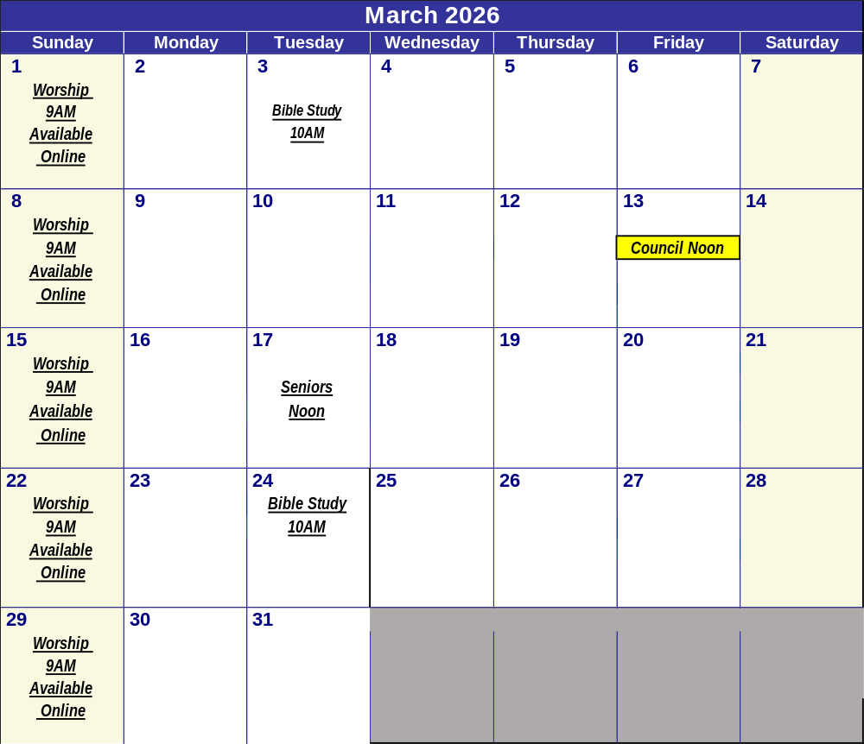

8

