CYBIT210 Module 8 Skills Assessment 1 – PowerShell for Windows Server

Background
PowerShell is crucial for Windows Server administration due to its powerful scripting capabilities, which enable automation of tasks, remote management, and efficient handling of complex systems. It allows administrators to manage various aspects of Windows systems, including hardware, software, network configurations, and security settings.

PowerShell is used by IT system administrators and help desk workers to:
- Automate redundant tasks
- Manage IT environments on scale
- Access hard-to-find user information

Objective
To get acquainted with PowerShell structure through cmdlets and scripts.

Required Equipment
- Windows Server 2022 VM

Part 1 PowerShell Roles and Features Cmdlets
You can complete other tasks such as add server roles, view services, stop a process, and view when the server was rebooted using PowerShell.
- Power on XX-S1 and sign in.
- Right-click Start and then click Terminal. It will open to PowerShell.
- To get a list of all available roles on Windows Server, type the following command:
Get-WindowsFeature and press Enter. Any role or feature installed will have a “X” in the square brackets.
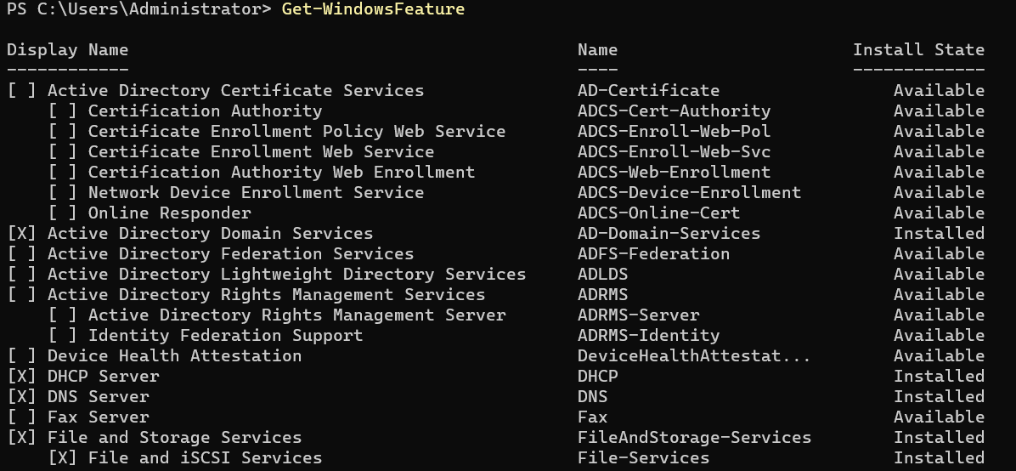
- To view a specific role with all its features such as Hyper-V, type the command:
Get-WindowsFeature Hyper*
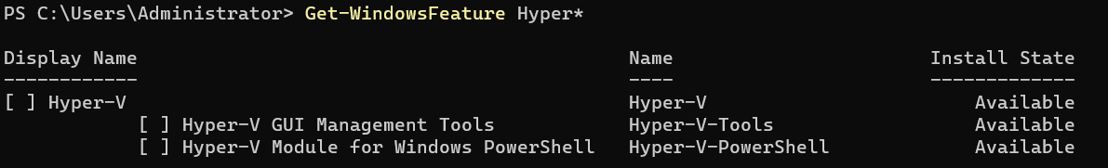
- Run the same command as in Step 2 but for PowerShell.
- Insert a screenshot showing the output for PowerShell.
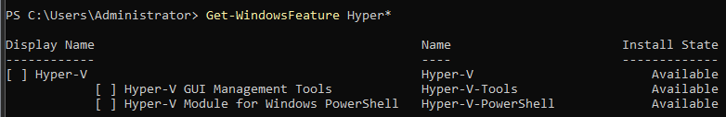
- To get a list of all installed roles and features in Windows Server, type the following command: Get-WindowsFeature | Where-Object {$_.InstallState -eq "Installed"} and press Enter.
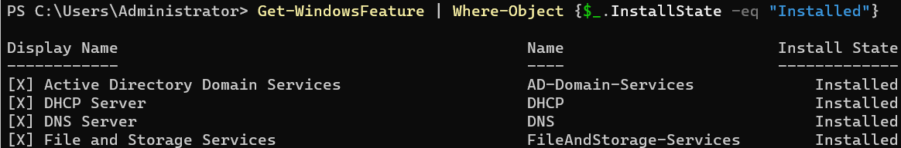
- Insert a screenshot showing the output up to Group Policy Management.
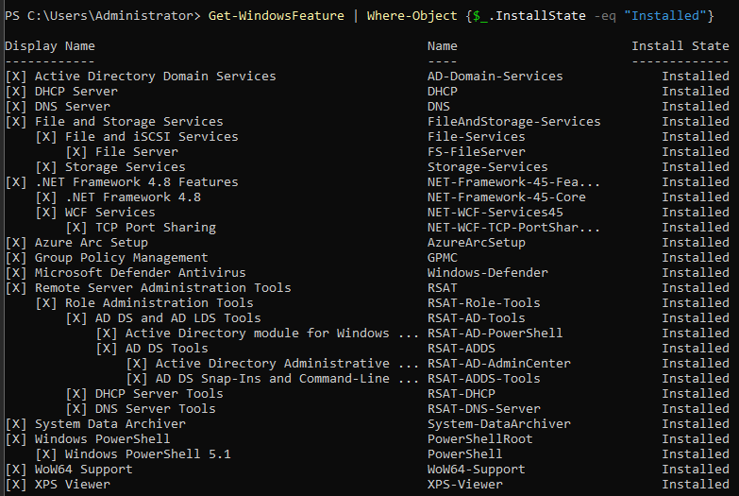
- To install Windows Deployment Services (WDS) using PowerShell, use the Install-WindowsFeature cmdlet with the WDS feature name and include the management tools, use the following command:
Install-WindowsFeature -Name WDS -IncludeManagementTools
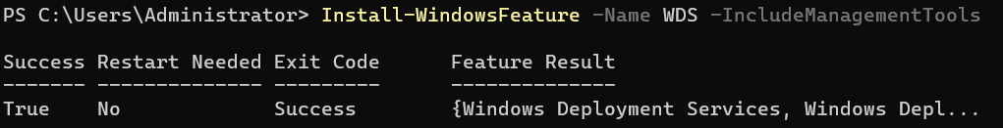
- To verify that WDS was installed and display the server computer name, type the command: Get-WindowsFeature WDS; (Get-ComputerInfo).CSName and press Enter.
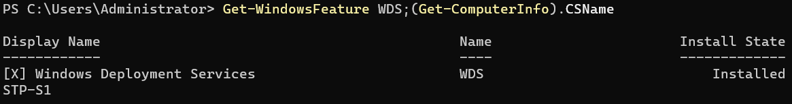
- Insert a screenshot with the result.
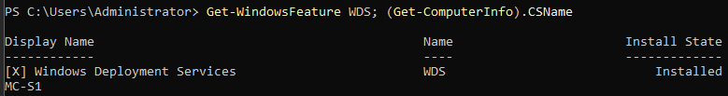
- To uninstall the DNS role, type the following command:
Remove-WindowsFeature WDS -IncludeManagementTools -Restart and press Enter. The -Restart parameter was added in case a reboot was required. Wait until it completes the operation.
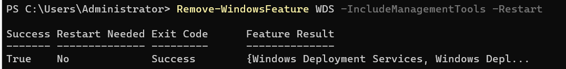
- The WDS server role and its Management Tools should have been uninstalled.
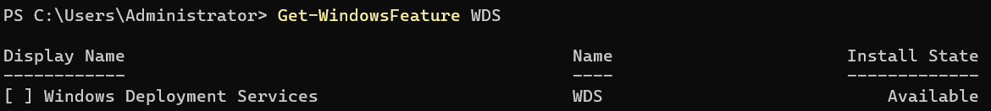

Part 2 Managing Domain OU, Users and Groups in PowerShell
- To create a new Organizational Unit (OU) in Active Directory using PowerShell, the New-ADOrganizationalUnit cmdlet is utilized. This cmdlet is part of the Active Directory module for PowerShell which is by default installed when a server becomes a domain controller.
- The basic syntax for creating a new OU involves specifying its name and the path where it should be created within the Active Directory domain.
  - The following is the syntax to create a new OU at the domain root:
New-ADOrganizationalUnit -Name "NewOUName" -Path "DC=yourdomain,DC=com"
    - -Name "NewOUName" specifies the name of the new OU to be created.
    - -Path "DC=yourdomain,DC=com" defines the Distinguished Name (DN) of the parent container or domain where the OU will reside. Replace "yourdomain" and "com" with your actual domain components.
- To create an OU named Music, run the command:
New-ADOrganizationalUnit -Name "Music" -Path "DC=xxxxx,DC=test"
Note: replace xxxxx with your last name
- Create another OU named Engineering.
- To view the OUs in Active Directory, run the following command:
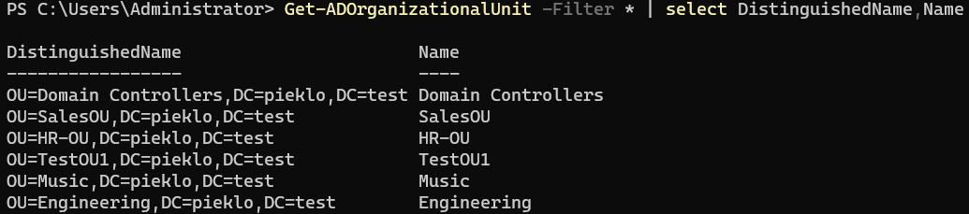
- Insert a screenshot showing the output.
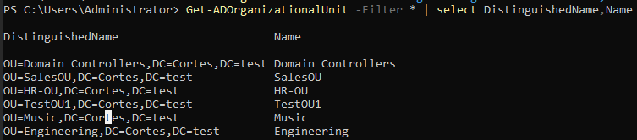
- The PowerShell New-ADUser cmdlet is used for creating a user in Active Directory. To see all the options for New-ADUser, type the command:
Get-Command New-ADUser –Syntax
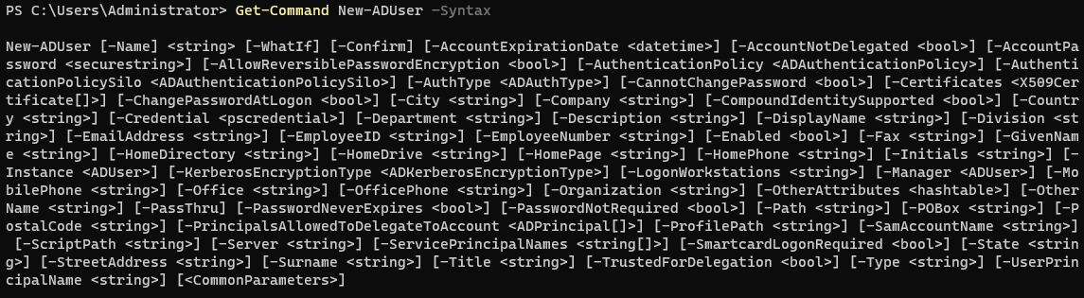
Note: Appendix 1 has a list of the New-ADUser parameters that you can use.
- To create the new domain user account, type the following command with PowerShell and press Enter: New-ADUser -Name “Clark Kent”
- To view the new domain user account, type the command:
Get-ADuser -Identity "Clark Kent"
Note: to view all attributes for the user, use the command:
Get-ADuser -Identity "user" -Properties * | Select-Object *
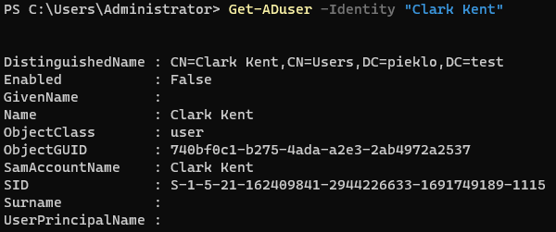
The following attributes are set by default for the user:
- The account is created in the “Users” container.
- The account is disabled.
- The account is a member of the Domain Users group.
- The user must reset the password at the first logon.
Many desired attributes are not populated. In particular, no password is set.
- Create the AD user Bruce Wayne with more attributes. Type the following command:
New-ADUser -Name "Bruce Wayne" -GivenName "Bruce" -Surname "Wayne" -SamAccountName "Bruce Wayne" -UserPrincipalName "bwayne@xxxxx.test" -Path "DC=xxxxx,DC=test" -AccountPassword(Read-Host -AsSecureString "Input Password") -Enabled $true and when prompt enter the password P@ssw0rd
Note: xxxxx will be your last name. Other new parameters are the following:
- The -AsSecureString parameter will encrypt the password.
- The Read-Host parameter will ask you to input a new password.
- The -Enable $true will enable the account.
- To confirm that the user was added, type the following command:
Get-ADuser -Identity "Bruce Wayne"
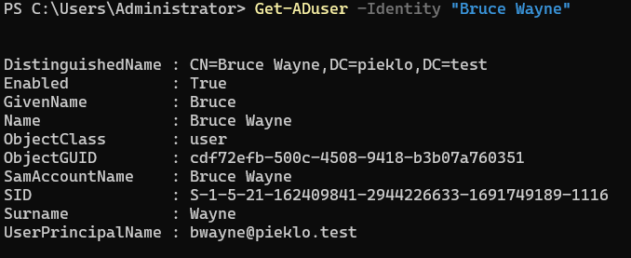
- Insert a screenshot showing the output of the command.
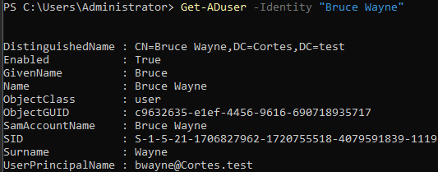
- Create another domain user, David Gilmour, now in the Music OU. Type the following command: New-ADUser -Name "David Gilmour" -GivenName "David" -Surname "Gilmour" -SamAccountName "David Gilmour" -UserPrincipalName "dgilmour@xxxxx.test" -Path "OU=Music,DC=xxxxx,DC=test" -AccountPassword(ConvertTo-SecureString -AsPlainText "P@ssw0rd" -Force) -ChangePasswordAtLogon $True -Enabled $true
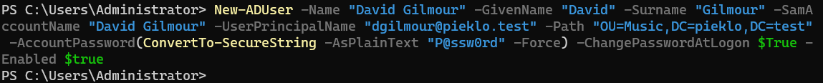
Note: xxxxx will be your last name. Other new parameters are the following:
- The -Path parameter now has the Music OU.
- The AccountPassword(ConvertTo-SecureString -AsPlainText "P@ssw0rd" -Force) parameter will encrypt the provided password P@ssw0rd
- The -ChangePasswordAtLogon $True parameter will force the user to change the password at the first logon.
- To see all David Gilmour domain account attributes, type the command:
Get-ADUser -Identity "David Gilmour" -Properties *
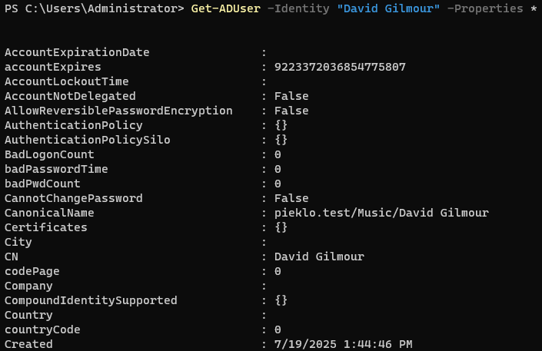
- Create another user Roger Waters as in Step 13.
- Use the command from Step 14 for Roger Waters.
- To view both new users in Music OU, type the command:
Get-ADUser -Filter * -searchbase "OU=Music,DC=xxxxx,DC=test" | select Name,DistinguishedName,UserPrincipalName
Note: xxxxx is your last name.
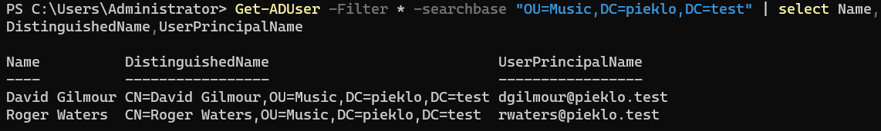
- Insert a screenshot of the result showing up to Created entry.
- To view all AD users, type the command:
Get-ADUser -Filter * -SearchBase "DC=xxxxx,DC=test" | select Name
Note: xxxxx will be your last name.
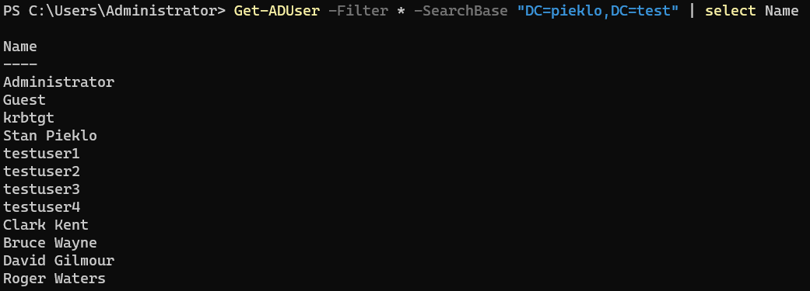
Note: to view users in a specific OU such as Music, type the command:
Get-ADUser -Filter * -SearchBase "OU=Music,DC=xxxxx,DC=test" | select Name
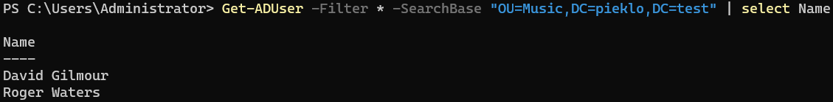
- Insert a screenshot showing all AD users.
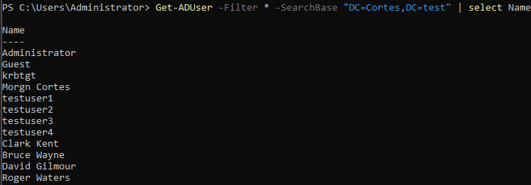
- To create new domain groups in PowerShell, the New-ADGroup cmdlet is used. This cmdlet is part of the Active Directory module, which needs to be imported if not already loaded. Key Parameters that can be used:
- -Name: Specifies the name of the new group. This is a mandatory parameter.
- -GroupScope: Defines the scope of the group. Possible values are DomainLocal, Global, or Universal. This is a mandatory parameter.
- -GroupCategory: Specifies whether the group is a Security group (for permissions) or a Distribution group (typically for email lists). Security is the default if not specified.
- -Path: Specifies the distinguished name (DN) of the OU or container where the group should be created. If not specified, the group is created in the default "Users" container.
- -DisplayName: Sets a display name for the group.
- -SamAccountName: Specifies the SAM account name for the group. If not provided, it defaults to the value of the -Name parameter.
- To create a Global Security Group named Engineering in the default Users container, type the following command:
New-ADGroup -Name "Engineering" -GroupScope Global -GroupCategory Security
- To view the new domain group, type the command:
Get-ADGroup -Identity "Engineering" | select Name,GroupScope,GroupCategory,DistinguishedName
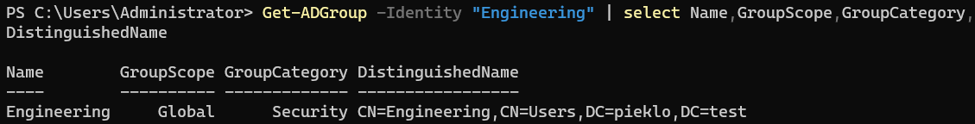
- Insert a screenshot showing the output.
- To create a Domain Local Security Group RockBands in the Music OU, type the command:
New-ADGroup -Name "RockBands" -GroupScope DomainLocal -GroupCategory Security -Path "OU=Music,DC=xxxxx,DC=test"
Note: xxxxx will be your last name.
- Confirm that the RockBands group is in the Music OU with the command: Get-ADGroup -Identity "Engineering" | select Name,GroupScope,GroupCategory,DistinguishedName
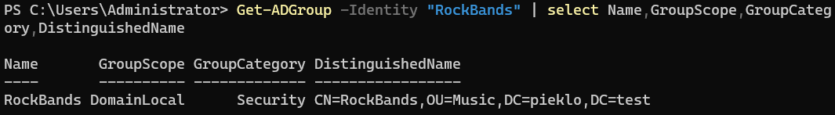
- Insert a screenshot showing the output.

- To add David Gilmour and Roger Waters to the Music group, type the following command:
Get-ADUser -Filter * -SearchBase "ou=Music,dc=xxxxx,dc=test" | ForEach-Object -process {Add-ADGroupMember -Identity "RockBands" -Members $_.SamAccountName}
- To display the list of users in the RockBands group, type the following command:
Get-ADGroupMember -Identity "RockBands" | select name,distinguishedName
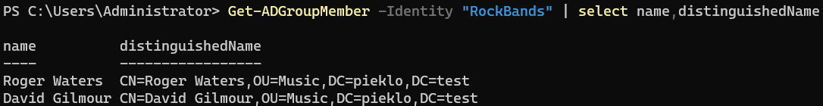
- Insert a screenshot of the result.
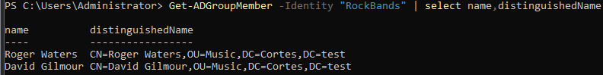
- To remove a user from a domain group using PowerShell, the Remove-ADGroupMember cmdlet is utilized. To remove Roger Waters from the RockBands group, type the command:
Remove-ADGroupMember -Identity "RockBands" -Members "Roger Waters"
By default, Remove-ADGroup prompts for confirmation before deleting the group. Press A to confirm deletion of the account.
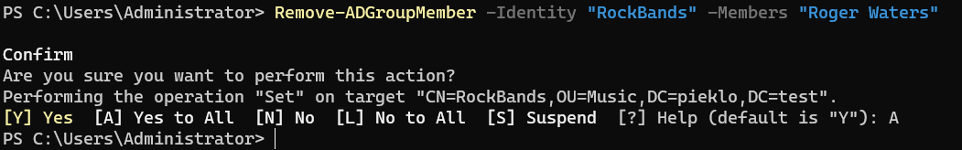
- To delete David Gilmour user account without the confirmation, type the following command:
Remove-ADGroupMember -Identity "RockBands" -Members "David Gilmour" -Confirm:$False
- Both users should no longer be in the RockBands group.
- To remove the RockBands group, type the following command:
Remove-ADGroup -Identity "RockBands" and press Enter. Press A to confirm deletion.
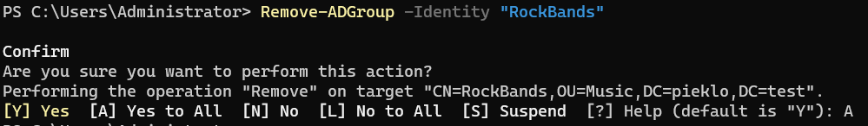
- To remove an AD user such as Roger Waters, type the command:
Remove-ADUser -Identity "Roger Waters" and press Enter. Press A to confirm deletion of the user.
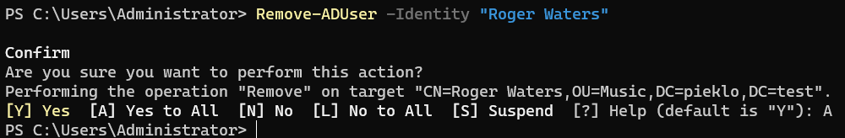
- Insert a screenshot of the result.
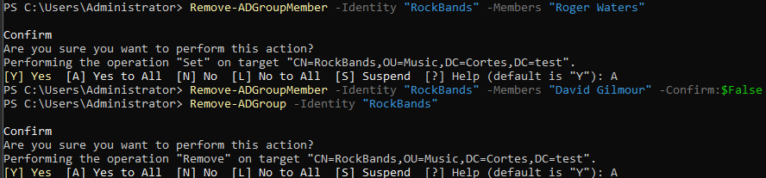
- By default, a domain OU has protection against accidental deletion.
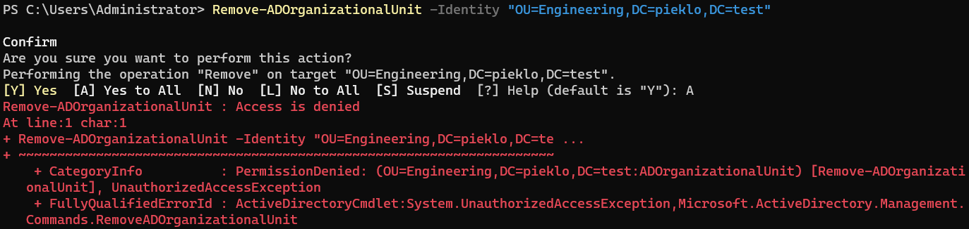
- To remove a domain OU that does not contain child objects (users, computers, other OUs) such as Engineering, do the following steps:
  - To remove accidental deletion from the OU, type the command:
Get-ADOrganizationalUnit -Identity "OU=Engineering,DC=xxxxx,DC=test" | Set-ADObject -ProtectedFromAccidentalDeletion:$false
  - To remove the OU without confirmation, type the command:
Remove-ADOrganizationalUnit -Identity "OU=Engineering,DC=xxxxx,DC=test" -Confirm:$False
Note: if there was any object in the OU, the -Recursive parameter can be used to delete the OU. Just a caution because this will permanently delete all contained objects.
- To confirm that the Engineering OU has been deleted, type the command:
Get-ADOrganizationalUnit -Filter * | select DistinguishedName,Name
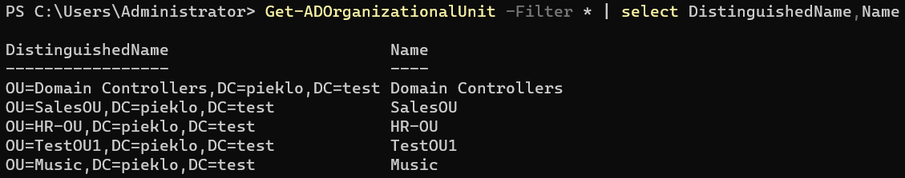
- Close any open windows and shut down Windows Server VM

Appendix 1 New-ADUser Parameters
The New-ADUser cmdlet offers more than 60 parameters, but you don’t need to know them all right away. Here are the ones most used to create AD user accounts:
Parameter | Used to
AccountExpirationDate | Specify the account’s expiration date
AccountPassword | Specify the account’s password
AuthType | Select the authentication type when running the command
CannotChangePassword | Prevent the account owner from changing the password (usually used for service accounts)
ChangePasswordAtLogon | Force the user to change the account password at the next login
City | Specify the city for the user account
Company | Specify the company for the user account
Confirm | Get a confirmation prompt to run the cmdlet
Country | Specify the country for the user account
Credential | Run the command with alternative credentials
Department | Specify the user’s department
Description | Specify a description for the user account
DisplayName | Specify the display name of the account
EmailAddress | Specify the account’s email address
EmployeeID | Specify the user’s employee ID
Enabled | Enable the user account
Instance | Create a user account based on an existing account, such as one with the same department and title properties as the account you are creating
Manager | Specify the manager of the user account
Office | Specify the office attribute of the user account
Organization | Specify the user’s organization
OtherAttributes | Specify the value for an attribute for which there is no corresponding parameter in the cmdlet, such as the extensionAttribute1 to 15 attributes
PasswordNeverExpires | Force the account’s password to never expire
PasswordNotRequired | Specify that the account, such as a service account, does not require a password
Path | Specify the OU path to create the user account in
SamAccountName | Specify the account’s SAMAccountName attribute, a logon name used to support clients and servers running earlier versions of Windows, such as Windows NT 4.0, Windows 95 or LAN Manager
Server | Connect to an alternate DC while running the command
State | Specify the user’s US state
StreetAddress | Specify the user’s address
Title | Specify the user’s title
Type | Specify the user object’s type, such as a normal user or an inetOrgPerson user
UserPrincipalName | Specify the account’s userPrincipalName (UPN), which is typically the name that the user will use to log on
WhatIf | See what the output of the cmdlet would be without actually running it

Resources
https://docs.microsoft.com/en-us/powershell/module/microsoft.powershell.management/?view=powershell-7
https://www.thomasmaurer.ch/2016/02/basic-networking-powershell-cmdlets-cheatsheet-to-replace-netsh-ipconfig-nslookup-and-more/
https://thinkpowershell.com/configure-static-ip-address-or-dhcp/
https://docs.microsoft.com/en-us/powershell/module/microsoft.powershell.management/get-eventlog?view=powershell-5.1
https://www.guru99.com/powershell-tutorial.html#12
https://woshub.com/configure-windows-server-core-basic-commands/
https://tunnelix.com/30-basic-powershell-commands-to-start-with-windows-server/
https://www.ionos.com/digitalguide/server/know-how/windows-powershell/#:~:text=Windows%20PowerShell%20makes%20it%20possible,can%20do%20in%20our%20article.
https://blog.netwrix.com/how-to-create-new-active-directory-users-with-powershell

