8
La Crónica del Calvario
¡Compartir la palabra – Preparar discípulos – Servir a todos en el amor de Cristo!
abril 2026
Volumen 90 – Número 04
The Calvary Chronicle
Share the Gospel – Prepare Disciples –
Serve All in Christ’s Love!
April 2026
Volume 90– Number 04

One Church - One Congregation – One Chronicle
Una iglesia - Una Congregación – Una Crónica
04/02/2026- Maundy Thursday
Exodus 12:1-10 Ps. 116:1-2,12-1 1st Corinthians 11:23-26 John 13:1-7, 31-35
04/03/2026- Good Friday
Isaiah 52:13-53:12 Ps. 22 Hebrews 4:14-16,5:7-9 John 18:1-19:42
04/05/2026- Easter
Acts 10:34-43 Ps. 118:1-2,14-24 Colossians 3:1-4 Matthew 28:1-10
04/12/2026- Second Sunday of Easter
Acts 2:14,22-32 Ps. 16 1 Peter 1:3-9 John 20:19-31
04/19/2026- Third Sunday of Easter
Acts 2:14,36-41 Ps. 116:1-4,12-19 1 Peter 1:17-23 Luke 24:13-35
04/26/2026-Fourth Sunday of Easter
Acts 2:42-47 Ps. 23 1 Peter 2:19-25 John 10:1-10

Calvary Evangelical Lutheran Church
6149 S. Kenneth Ave. Chicago, IL 60629
(773) 767-7400
Email: calvaryluther@sbcglobal.net
URL: chicagolutheran.org
facebook.com/chicagolutheran.org

1

Pastor’s Column- April 2026
Then Jesus told them plainly, “Lazarus is dead. For your sake I am glad I was not there, so that you may believe. But let us go to him.” Thomas, who was called the Twin, said to his fellow disciples, “Let us also go, that we may die with him.” (John 11:14-16, NRSVUE)

As I shared in March, grief is a natural process as we approach Calvary’s final weeks and worship service, even as we also have much to celebrate and be thankful for. I think it is healthy and necessary in order to be ready to begin a new life in a new congregation.
In the story of Jesus raising Lazarus that we heard last Sunday, Jesus indicates that Lazarus’s death was necessary in order for the disciples to have faith in Jesus and the resurrection. Thomas, who is better known for his doubting Jesus’s resurrection until he saw it for himself, expressed a willingness to die with and for Jesus. (Eventually Thomas did die a martyr, as most of the other apostles did also.)
We can’t fully understand or appreciate Easter Sunday unless we also experience Good Friday. Jesus could not offer us eternal life until after he had died for our sins on the cross. He entered not into glory until he first was crucified. The prayer of the day for Monday in Holy Week in Evangelical Lutheran Worship says, “O God, your Son chose the path that led to pain before joy and to the cross before glory. Plant his cross in our hearts, so that in its power and love we may come at last to joy and glory….”
There is no resurrection without death. By walking with Jesus through his death and resurrection, we will be much more able to know and feel that he walks with us as our congregation nears its end and as we continue lives of faith in other places and people who follow the same Lord.

In our crucified and resurrected Savior,
Pastor Cox

2
Final Worship RSVP
Calvary’s final worship service will be Sunday, May 17, 2026 at 10:00 a.m., one hour later than the usual time. A lunch catered from the European Chalet Restaurant will follow the worship service. Please RSVP to Cheryl Schwartz or Gina Misch by phone, email, or in person, or by leaving a message on the church office phone 773-767-7400, by Sunday, May 3 if you plan to attend the service and lunch.
Suggest a hymn
Active Calvary members are invited to suggest a favorite hymn for our final month of worship. Please give the title or first line of the hymn (and the hymn number if known) to anyone on the Worship and Music committee – Pastor Cox, Brother Wheeler, or Cheryl Schwartz, by Sunday, April 12. Suggestions will be considered if seasonally appropriate for a Sunday in May.

Transition to a new congregation and congregation member records
Letters of transfer are offered to members of a congregation who transfer to another congregation in the same denomination. Letters of transfer may include important dates such as birth, baptism, and confirmation when this information is available in the original congregation’s register.
Congregations’ offices usually do not keep copies of certificates of baptism, confirmation, or marriage. The information should be entered into the congregation’s register, and if official confirmation of this type of data is requested, an official letter can be written which certifies the person’s name, church name and location, and date of the sacrament or rite.
Pastor Carla Thompson-Powell has given Pastor Cox a list of ELCA congregations within an eight-mile radius of Calvary, which he can give anyone upon request. Many members live a fair distance from Calvary, however. If anyone is interested in a list of ELCA churches near your home address, please ask Pastor Cox.

3

Bible Study
Calvary’s final Bible study sessions will be on Tuesday, April 14 and Tuesday, April 28 at 10:00 a.m. with brief intercessory prayer at the conclusion of each session, finishing before noon. We are studying the book of Psalms. All are welcome.
Calvary Seniors
Calvary Seniors has been meeting on the third Tuesday of the month and will meet on Tuesday, April 21 at noon. For more information, please contact Elaine Lebron.
LSSI – Good Shepherd Sunday
The fourth Sunday of Easter, often called Good Shepherd Sunday, falls on April 26 this year. For several years, Calvary has provided information about and has collected donations for Lutheran Social Services of Illinois (LSSI) on this date. Please consider making a donation to LSSI this year, through designated envelopes at worship or online at https://www.lssi.org, where one can also read current information about LSSI’s various ministries with affordable housing, seniors, people with intellectual or developmental disabilities, addiction treatment, prisoners and their families, and foster care.
Holy Week Schedule
(If unable to attend Calvary’s service at the given time, you are welcome to join Santa Teresa at its service time shown in brackets and italics.)

Palm Sunday, March 29 /Domingo de Ramos, 29 de marzo
9:00 a.m. – Liturgy of Palms and Passion with Communion
Maundy Thursday, April 2 / Jueves Santo, 2 de abril
11:00 a.m. (Calvary) (English)
[7:30 p.m. - Santa Teresa, 6201 S. St. Louis (bilingual)]
Good Friday, April 3/ Viernes Santo, 3 de abril
[2:00 p.m. service w/Via Crucis at Santa Teresa (bilingual)]
5:45 p.m. Stations of the Cross (bilingual)
6:30 p.m. Good Friday Service (bilingual)
[Saturday, April 4 Easter Vigil 8:00 p.m. - Santa Teresa /Vigilia Pascual (Sábado de Gloria)]
Easter Sunday, April 5 / Domingo de Pascua, 5 de abril
9:00 a.m. – Worship Service with Holy Communion
[10:30 bilingual & 12:30 español - Santa Teresa, 6201 S. St. Louis]
4

Suggestions for Donations of Calvary’s Assets
Calvary still has expenses to pay through the time of our closing, so we thank everyone for your continued giving of pledges or other offerings. Upon closing, at least 50% of unspent financial assets will go to the Metropolitan Chicago Synod of the ELCA. However, the council will vote to donate other remaining assets to other church or non-profit organizations. Council is willing to receive suggestions from active members for one or two 501(c)3 (church or non-profit) organizations. Please write down your suggestion and email or give it directly to Gina, council secretary, or Cheryl Schwartz treasurer, by April 12, 2026 (Second Sunday of Easter). It will be helpful to include the exact name and physical or online address of the organization, too.
Twelve Reasons Why a Local Pastor Stopped Attending Sports Events
(Compare these reasons to those people give for not attending church!)
- Every time I went, they asked me for money.
- The people with whom I had to sit didn’t seem very friendly.
- The seats were hard.
- The coach never came to see me.
- The referee made a decision with which I could not agree.
- I was sitting with some hypocrites—they came only to see what others were wearing.
- Some games went into overtime and I was late getting home.
- The band played some songs I had never heard before.
- The games are scheduled when I want to do other things.
- My parents took me to too many games when I was growing up.
- Since I read a book on sports, I feel that I known more than the coaches, anyhow.
- I don’t want to take my children because I want them to choose for themselves which sport they like best.
(from JoyfulNoiseletter.com, reprinted in The Anglican Digest, winter 2025)

5
Calvary Recollections
(We continue to share excerpts from Calvary’s historical documents and artifacts. The previous two months’ excerpts were from ten and thirty years ago; this month’s recollections are from about sixty years ago, from the oldest binder of congregation council minutes that we have found so far.)

May 1964:
Worship Committee: Council accepted the communion schedule for a year and the motion to publish it in the Chronicle. Communion was offered on one Sunday per month and also on holy days.

“The Sector Plan” – the congregation is divided into 23 sections. A Deacon was assigned to his section for the rest of his term on Council, serving as an assistant pastor to those people but encouraging them to take spiritual problems to the Pastor. He would visit people in their home, seek to involve them in Sunday School, teaching, choirs, Lutheran Church Women, Luther League, etc. and keep a close check on those who were not attending worship regularly. Calvary’s constitution defined the deacon’s responsibility as “To support the Pastor in fulfilling his calling and in so doing to visit the sick, the infirm and the spiritually indifferent, to minister to the poor and distressed, and to seek to bring the unchurched into the fold of Christ.”

Pastor Berry submitted to council the names of eleven people who had applied for membership to Calvary Church and would be received on Trinity Sunday, May 24 at the 11:00 a.m. service.
June 1964: A committee formed of John Warner, James Hartley, and Bruno Haslinger interviewed six of Calvary’s young people and awarded Sharon Sandlin and Steven Viktora as Youths of the Year.
August 1964: Mr. Godfrey, the sexton, wrote a letter to Pastor Berry and the Church Council “asking for a $50 a month increase in salary, which in terms of dollars and cents will give me less that $10 per day for a 12 hour day.” … “In reference to the buildings of the church and the surrounding areas, I find it impossible to police them 24 hours a day. So it is my suggestion to the Pastor and to the Council that the facilities of Our Church be open only upon request.”

6
October 1964:
Building: Council passed a motion to dissolve the original Calvary Building for Christ committee due to lack of attendance and to appoint a new committee. Cliff Roberts reported that seven architects were interviewed, and a motion was passed to hire Robert Swanson of Evanston to redevelop Calvary’s Parish Building. Also, council agreed with the Organ Committee’s request to have Sunday, October 25, as the official Organ Dedication Day for the new organ. The previous electronic organ was sold to Lutheran Church of the Incarnation at 4901 W. 79th St. in Oak Lawn for $500.
1965-1966 Report on Social Ministry: Special consultations were described with Lutheran Welfare Services of Illinois, Augustana Hospital, Lutheran Hospital – Moline, Lutheran Charities Federation, and Bethphage Mission. Also, the committee tried to share information about, and encouraged individual involvement in, Civil Rights, consistent with the policies of the Lutheran Church in America. The committee also encouraged synod staff to provide special interest discussions on controversial social issues.
April 1965: Pastor Berry submitted his resignation letter to the church council. He expressed gratitude for his seven and a half years at Calvary, expressed concern about low attendance at Divine Worship and Holy Communion, encouraged them to not expect the pastor to do everything to change that, and urged them to complete the parish building construction.
August 8, 1965: In a special congregational meeting, of 146 members present, all voting members unanimously voted to call Pastor Walter Wittman as Calvary’s next pastor.
December 1965: The council accepted the worship committee’s recommendation to extend communion services to two Sundays per month—at 9:00 a.m. on the first Sunday and 11:00 a.m. on the third Sunday. Also, 703 confirmed members were reported on the active roll.
1966: The proposed budget for 1966 includes income of $58,965 and expenses of $68,535, for a reported deficit of $9,570.

7
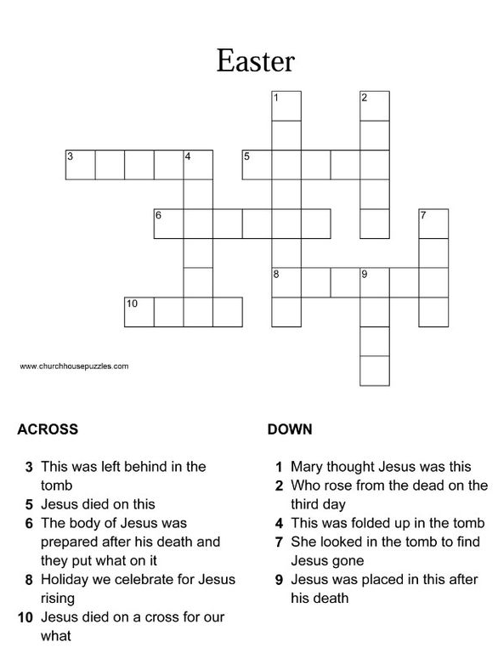
8
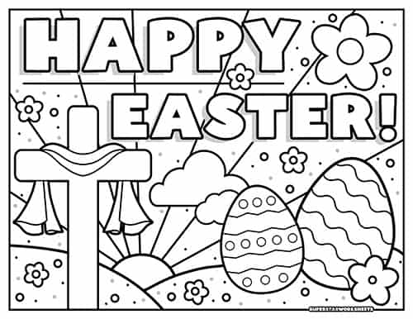

9
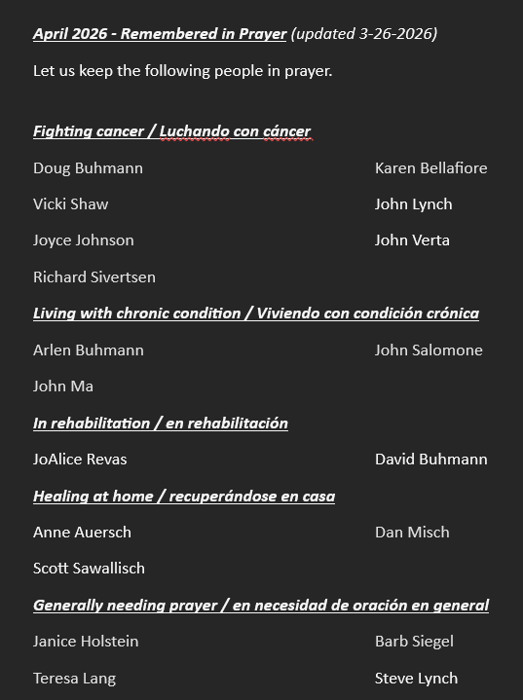

10

Happy Birthday! Happy Anniversary!
¡Feliz Cumpleaños! ¡feliz aniversario!
Sal Campos April 8th
Rudy Cortes Jr. April 30th

Memorials
In Honnor of Rudy Cortes Jr. Birthday (Morgan Cortes)
In Memory of Don and Georgeina Sawallisch (Scott Sawallisch)

Verses for our Times:
“For the mind-set of the flesh is death,
but the mind-set of the Spirit is life and peace.”
(Romans 8:6, Holman Christian Standard Bible)

11

12

